Hamster Mouse

Final Design Report Template

Jared Hemauer: CAD & Manufacturing Engineer
Rylee Horney: Manufacturing Engineer & Financial Manager
Joseph Lopez: Coding Engineer & Project Manager
Keenan Keams: Testing & Design Engineer

Spring 2024 – Fall 2024

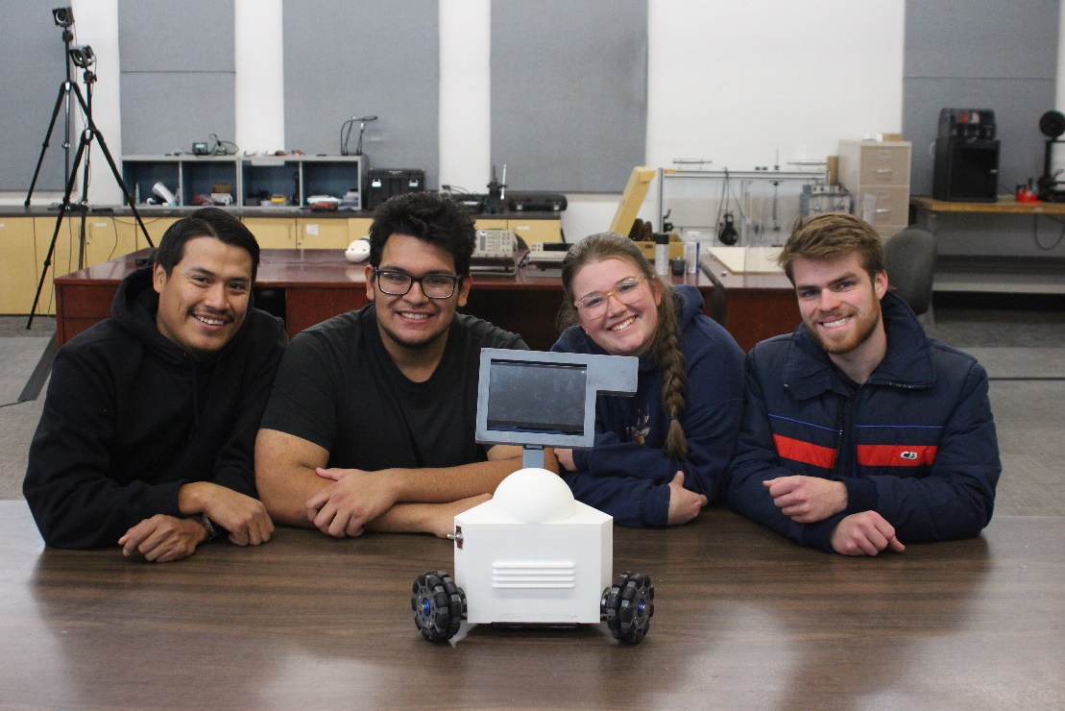

Project Sponsor: Reza Sharif-Rezavian
Sponsor Mentor: Terae Jones
Instructor: David Willy

DISCLAIMER
This report was prepared by students as part of a university course requirement. While considerable effort has been put into the project, it is not the work of licensed engineers and has not undergone the extensive verification that is common in the profession. The information, data, conclusions, and content of this report should not be relied on or utilized without thorough, independent testing and verification. University faculty members may have been associated with this project as advisors, sponsors, or course instructors, but as such they are not responsible for the accuracy of results or conclusions.

EXECUTIVE SUMMARY
The Hamster project is more than simply an engineering endeavor; it is a revolutionary idea for using technology and human-centered design principles to completely redefine the field of stroke rehabilitation. Fundamentally, the program shows a commitment to fulfilling the urgent need for stroke sufferers to have affordable, efficient rehabilitation therapies. The Hamster team set out on a mission to provide affordable access to physical therapy by building a portable, efficient robot that would treat patients in their homes. The team recognized the financial constraints and practical issues that individuals undergoing traditional treatment frequently face.
Since the start of development, the Hamster device's design and development process has been characterized by iterative approaches to improve and optimize key aspects of the device's functionality and design. For instance, the ergonomics, robustness, and ease of use of the chassis and casing were all optimized for a seamless and intuitive user experience. In the meantime, tests have been conducted on the motors and batteries to ensure optimal functionality, reliability, and efficiency. Moreover, precise motor control and navigation capabilities were added to the microcontroller code through the use of simulations and algorithms, enhancing the device's overall effectiveness and user experience.
Though there have been a few little delays, the project is moving forward well as of the writing of this report. Even with the odd bumps along the road, the group never gives up and keeps moving forward. For now, the main priority is finishing the CAD drawings, which are an essential part of the project's development stage. Furthermore, work has started on the code component, which presents a big obstacle because of its broad breadth and complexity. Starting the coding duties is a significant job that requires careful preparation and close mindfulness. However, the crew is still committed to overcoming these obstacles and moving forward with the project's goals. The project is on track to meet its goals and produce positive results with persistence and teamwork.
In the future, more design optimization will be prioritized to improve user experience and simplify functioning. Simultaneously, efforts will continue to be made to improve the code to guarantee prompt completion and accomplish the goal of allowing the robot to move in all directions. Although our team recognizes the size of the Hamster project, we also realize that other teams want to grow and develop this project in the future. The project aims to get to a point where stroke sufferers everywhere may benefit from it. We aim to develop a flexible and user-friendly platform that may enhance rehabilitation efforts and the quality of life for those recovering from stroke-related disabilities by utilizing cutting-edge design solutions and coding methods.

TABLE OF CONTENTS
Contents
DISCLAIMER 1
EXECUTIVE SUMMARY 2
TABLE OF CONTENTS 3
1 BACKGROUND 1
1.1 Project Description 1
1.2 Deliverables 1
1.3 Success Metrics 2
2 REQUIREMENTS 4
2.1 Customer Requirements (CRs) 4
2.2 Engineering Requirements (ERs) 5
2.3 House of Quality (HoQ) 5
3 Research Within Your Design Space 6
3.1 Benchmarking 6
3.2 Literature Review 7
3.2.1 Joseph Lopez: 7
3.2.2 Jared Hemauer: 10
3.2.3 Rylee Horney: 14
3.2.4 Keenan Keams: 16
3.3 Mathematical Modeling 18
3.3.1 Battery Life – Joe Lopez 18
3.3.2 Moment Upon a Beam on a Support – Joe Lopez 18
3.3.3 Omni-directional Wheel Control Using Vectors – Jared Hemauer 19
3.3.4 Motor Speed Calculations – Jared Hemauer 19
3.3.5 Shear Deformation of PLA for Structural Components – Rylee Horney 20
3.3.6 Instruction Execution Time – Rylee Horney 20
3.3.7 Power of the Motor – Keenan Keams 21
3.3.8 Power Torque Calculation – Keenan Keams 22
4 Design Concepts 23
4.1 Functional Decomposition 23
4.2 Concept Generation 24
4.2.1 Hand Attachment System – Joe Lopez 24
4.2.2 Wheel Selection and Layout – Jared Hemauer 24
4.2.3 Chassis Design – Rylee Horney 25
4.2.4 Screen Placement – Keenan Keams 26
4.3 Selection Criteria 27
4.4 Concept Selection 28
5 Schedule and Budget 29
5.1 Schedule 29
5.2 Budget 29
5.3 Bill of Materials (BoM) 30
6 Design Validation and Initial Prototyping 31
6.1 Failure Modes and Effects Analysis (FMEA) 31
6.2 Initial Prototyping 32
6.2.1 Prototype 1 32
6.2.2 Prototype 2 33
6.3 Other Engineering Calculations 33
6.3.1 Motor Torque Requirements – Joe Lopez 33
6.3.2 Wheel Speeds Using MATLAB – Joe Lopez & Rylee Horney 33
6.3.3 FEA- Jared Hemauer 34
6.3.4 Battery Amperage – Keenan Keams 36
6.4 Future Testing Potential 36
7 Final Hardware 37
7.1 Final Physical Design 37
8 Final Testing 41
8.1 Top level testing summary table 41
8.2 Detailed Testing Plan 42
8.2.1 Force Output Test 42
8.2.1.1 Summary 42
8.2.1.2 Procedure 42
8.2.1.3 Results 42
8.2.2 Prony Brake 43
8.2.2.1 Summary 43
8.2.2.2 Procedure 43
8.2.2.3 Results 43
8.2.3 Position Test 43
8.2.3.1 Summary 43
8.2.3.2 Procedure 44
8.2.3.3 Results 44
8.2.4 Duration Test 44
8.2.4.1 Summary 44
8.2.4.2 Procedure 44
8.2.4.3 Results 44
9 Future work 45
10 CONCLUSIONS 46
11 REFERENCES 47
12 APPENDICES 50
12.1 Appendix A: Gantt Chart for Project 50
12.2 Appendix B: Manufacturing BOM 51
12.3 Appendix C: FMEA Table 52
12.4 Appendix D: MATLAB Code for Section 6.3.2 52

BACKGROUND
Included in the background will be information on the Hamster project description, project deliverables, and overall success metrics. The project description will introduce the client's entire project idea and explain why this project is significant beyond the engineering phenomena. This will contain all budgetary requirements and fundraising strategies. The deliverables section of this chapter will include the project's significant components, such as client and course needs. The success metrics section of the chapter will go over how the team defines success for our project and how it will be measured.

Project Description
The Hamster Project seeks to create a dynamic solution to assist stroke patients in their rehabilitation process. The development of a motorized robot resembling a mouse meant to aid physical rehabilitation activities for people with reduced movement after a stroke, is central to this project. The device's mobility enables effortless operation on any tabletop surface, which is convenient for patients. Beyond its practicality, the initiative has substantial social ramifications, with the potential to reduce the financial burden associated with stroke therapy by providing a more cost-effective alternative. Furthermore, by allowing outpatient therapy and reducing in-house patient visits, the idea simplifies the rehabilitation process while simultaneously increasing patient autonomy. With a $1000 budget, our team plans to raise extra funds through family donations and material sponsorships from local businesses such as Elemental Motors in Flagstaff, assuring the project's success. In accordance with the capstone class requirements, each team is expected to contribute a minimum of 10% of the project's budget. Our team has pledged to raise $100 to satisfy this responsibility. We want to get crucial components such as motors and microcontrollers by leveraging the assistance of family and developing relationships with local businesses, notably Elemental Motors. We want to achieve the Hamster Project's goals through effective resource allocation and community cooperation while sticking to cost limits and optimizing impact.

Deliverables
The Hamster Project requires many deliverables that must meet both the client's expectations and the capstone course's criteria. The customer has set precise parameters that are related to the project's ultimate design, aiming for a tiny, lightweight robot capable of reaching a speed of 1 m/s, exerting 10 N of force unidirectionally, and generating 5 Nm of torque. Furthermore, the gadget must function for at least 30 minutes on a single c on a single charge for at least 30 minutes charge while staying highly portable. The inclusion of a non-functional screen acts as a proof of concept, improving the overall user experience for stroke patients in rehabilitation. These standards demonstrate the client's determination to ensure the device's efficacy in assisting patients' rehabilitation journeys. By the end of the project the team will have manufactured a functional omni directional robot for the client that meets the standards previously mentioned.
In parallel, the capstone course imposes its own set of requirements, focusing on cooperation, project management, and effective communication. The course's objectives include demonstrating appropriate analysis for components to be purchased or made by the team, and effective prototypes that answer questions regarding the project, and reports discussing progress throughout the project. The team plans to build the chassis components for the robot as the first prototype. This will allow the team to understand the true size of the robot. The second prototype will be showing how the motor is controlled. Understanding how we can control the motor will allow the team to move forward in manufacturing and purchasing the other two motors and wheels. Furthermore, the capacity to communicate current work and strategically plan future tasks is critical, allowing for a methodical approach to project execution. Given the project's continuance into the next semester, flexibility becomes critical since the goals and needs of both the course and the customer may change over time, forcing occasional schedule modifications to stay on track with project objectives. The team seeks to effectively manage these multiple challenges through rigorous coordination and attention to course requirements coordination and attention to course requirements, the team seeks to effectively manage these multiple challenges, eventually producing a robust and impactful solution for stroke recovery.

Success Metrics
To be considered successful, the Hamster Project must meet certain essential criteria, as specified by both the client's expectations and the capstone course's requirements. First, the gadget must meet all design parameters, such as size, weight, speed, force output, torque, and battery life. These characteristics function as quantifiable standards against which the device's performance will be measured. Testing methods will be devised to evaluate the device's functioning, including rigorous testing of its movement capabilities, force exertion, and endurance. Calculations will be performed to ensure that the device satisfies the stated standards, including exact measurements of speed, force, and torque output compared to predefined thresholds. Furthermore, the inclusion of a non-functional screen acts as a conceptual element to improve user experience, offering an extra layer of validation to the design. While its functioning is not the major priority, its incorporation into a device design is crucial to achieving customer expectations. As a result, proper integration, and placement of the screen within the device will be examined throughout the testing and assessment phases. In addition to technical performance, the project's success will be measured by the team's adherence to project management principles and successful teamwork. This includes a fair division of labor among team members, timely completion of duties, and initiative-taking communication to resolve any issues or setbacks experienced during the project's lifespan. The team's ability to give progress updates and clearly define upcoming tasks displays their competence for project planning and execution. The Hamster Project's success will be evaluated by its ability to meet or surpass the specified design criteria, pass stringent testing processes, and exhibit excellent project management and cooperation. By satisfying these objectives, the project will not only meet the client's expectations but also demonstrate the team's ability to offer a feasible solution for stroke recovery.

REQUIREMENTS
In this chapter, there will be three main subsections presented. These subsections include the customer requirements, the engineering requirements, and the house of quality created from the prior sections. The customer requirements section will include a list of all requirements provided by the client to date and how they are defined. The engineering requirements will be introduced in a list that is quantified and provides targets regarding each requirement. Lastly, these prior two sections will be placed into a QFD where comparisons and rankings of each requirement will be provided.

Customer Requirements (CRs)
Provided is a list of the customer requirements from the initial proposal and feedback from meetings.

- Size – the client wants the device to be small enough that it is portable and can move over the surface of a desk.

- Speed – the device will need to be able to reach a speed of up to 1 m/s in any direction. This is to allow for the device to keep up with a patient’s hand speed.

- Force – must be able to produce a force of up to 10 N to the patient’s hand in any direction or 5 Nm of torque about the vertical axis.

- Internal Friction – when motors are not being used the device must be able to be moved with less than 5N of force.

- Backlash- when motors are off the device must not move more than 0.1mm.

- Run Time – device must run for at least 30 minutes on a single charge.

- Interface: device must be able to receive commands from a computer and send its position back to the computer in (x, y) coordinates.

- Screen – there must be a touch screen that is at least four inches on the device.

- Cost – total production of the device must be <$500.

- Microcontroller – client prefers Raspberry Pi to be used due to faster processing speeds.

- Ease of Use – should not require more than a number for the force being applied and a direction.

- Comfortable – the device should be comfortable in a patient’s hand.

Engineering Requirements (ERs)
Below is the list of engineering requirements chosen based on the customer requirements stated in section 2.1.

- Motor Output (kW) – the motor must be able to produce enough rotations per minute to meet speed requirement of 1 m/s.

- Battery Life (kW hr ) – needs to last with three motors and the other electrical components for at least 30 minutes.

- Battery Amperage (A) - need to be able to produce enough current for all components in the robot at least 6 Ah (i.e. three motors, raspberry pi, sensors, motor controller, and screen)

- Size (ft) – less than 1ftx1ftx1ft

- CPU Speed (s) – the microcontroller needs to be able to send commands quickly so there is minimal delay in the movement of the robot. (16 MHz)

- Weight (lb.)- the device should not weigh more than 8 lbs. to allow for patient to be able to move it easily.

House of Quality (HoQ)
The Quality Function Deployment (QFD) is used for finding the importance of the customer requirements and how each technical requirement relates to it. The customer requirements are labeled on the left and are given by the client regarding what they want to see in the product and each one is weighed from 1 to 5 regarding importance. The technical importance is quantitative measurements used to determine how each customer requirement will be met. The technical requirements are numbered from 0-10 regarding their importance to each of the customer requirements, a blank space means a zero. Above the technical requirements, there is a triangle used to show how different technical requirements relate to each other. At the bottom of the QFD the ranking of requirements is made using the customer ratings and the technical importance values, the totals are calculated to show which technical requirement is the most important. Finally, to the far right, there is a comparison of related products showing how each of them scores using the customer requirements.

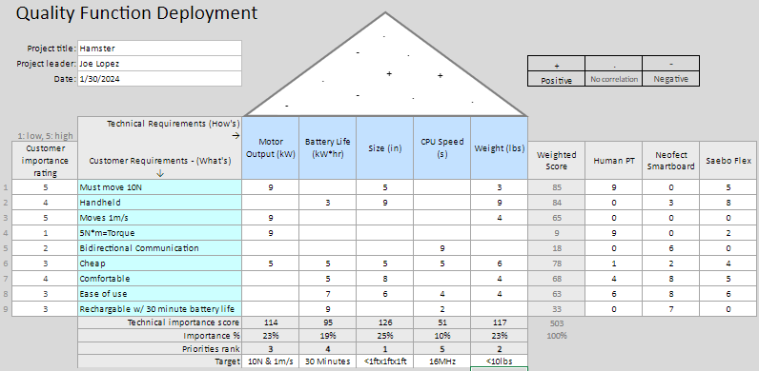
Figure 1: Hamster Project House of Quality

Research Within Your Design Space

Benchmarking
Several innovative systems stand out in the field of system-level benchmarking for state-of-the-art rehabilitation devices such as the Hamster project due to their new techniques and improved functionality. One notable device is ReWalk Robotics' Exoskeleton, which is known for its advanced design that allows people with lower limb problems to walk freely. The ReWalk Exoskeleton, which incorporates innovative sensing technologies and easy control mechanisms, establishes an elevated level for mobility-assistance systems used in rehabilitation. Another notable device is Ekso Bionics' Ekso GT [41], distinguished by its intuitive user interface and adaptable robotic technology, providing tailored rehabilitation programs for stroke survivors and persons with neurological disabilities. Furthermore, the Kinova Robotics Jaco Assistive Robot [42] excels in providing upper limb support and assistance, with precise control capabilities and ergonomic design elements geared to improve the rehabilitation experience for people with limited dexterity.

Benchmarking efforts at the subsystem level are directed on analyzing certain components and capabilities that are critical to the Hamster device's performance and usability. This includes comparing various subsystems, such as motor systems, control interfaces, and feedback mechanisms, to industry standards and best practices. Motor systems, for example, are evaluated using parameters like torque production, efficiency, and dependability to guarantee optimal performance in providing mobility aid to stroke patients. Similarly, control interfaces are assessed for their intuitiveness, responsiveness, and adaptability to meet varied user demands and preferences. Furthermore, feedback mechanisms, such as sensory feedback and user feedback interfaces, are evaluated to determine their usefulness in giving real-time input and increasing user involvement throughout rehabilitation sessions. The Hamster project intends to create a robust and user-friendly rehabilitation support device by integrating innovative technology and features via rigorous subsystem-level benchmarking.

Literature Review

Joseph Lopez:
[1] “A Review of Rehabilitation Devices to Promote Upper Limb Function Following Stroke,”

The initial source makes a substantial contribution to the fundamental knowledge of our team's effort, which is focused on constructing a tiny robot to assist stroke patients with upper limb rehabilitation. This source investigates existing gadgets on the market built for comparable objectives, offering useful insights into the present landscape of assistive technology for stroke rehabilitation. As our team is still in the early phases of the project, this material is an important reference point, providing a full overview of the features, functions, and limits of existing devices. Analyzing these proven solutions can help us uncover market gaps while also refining our project goals and design concerns. Furthermore, the source acts as a baseline for assessing the efficacy of our future robotic rehabilitation solution, leading us through the development process to assure innovation and improvement over existing alternatives.

[2] “A Low-Cost Tele-Rehabilitation Device for Training of Wrist and Finger Functions After Stroke,”

This source is especially useful for our team, which is in the initial stages of designing a small robot to help stroke patients with rehabilitation, with a focus on improving fine motor skills in fingers and smaller appendages. The source digs into the world of low-cost rehabilitation gadgets designed for stroke sufferers, giving light on novel solutions that focus on the precise movements of tiny limbs. Given the nascent stage of our research, this source becomes an invaluable resource, giving insights into cost-effective alternatives and prospective design considerations for our robot rehabilitation equipment. Understanding the tactics and technologies used in existing low-cost gadgets enables us to make educated decisions while designing and developing our robot, assuring both affordability and efficacy. As a result, the source acts as a strategic guide, assisting our team in overcoming the complexities of developing a feasible and accessible solution for stroke patients who require rehabilitation for their fingers and tiny appendages.

[3] “Wearable haptic devices for post-stroke gait rehabilitation,”

This source proved to be an excellent value to our team during the initial stages of our project, which focuses on the construction of a tiny robot to aid stroke victims in their recovery. This source, which focuses primarily on wearable stroke rehabilitation devices, explains breakthroughs and applications in the sector, providing relevant information that can affect the trajectory of our research. Because our team is still in its early phases, the knowledge obtained from this source serves as a critical basis for comprehending the growing landscape of wearable technology designed specifically for stroke recovery. By investigating the features, user experiences, and efficacy of wearable devices, we acquire a thorough grasp of the technology's potential and difficulties. This knowledge will help guide our design decisions and ensure that we include features that are in line with current trends in wearable stroke therapy equipment. In effect, this source acts as a compass, guiding us through the intricacies of incorporating wearable technology into our tiny robotic system for improved stroke patient rehabilitation.

[4]L. Riek, Healthcare robotics, vol. 60

This source emerges as a critical resource for our team as we begin the basic steps of constructing a tiny robot designed to support stroke sufferers in their recovery journey. While not solely concerned with stroke rehabilitation, the site offers useful insights by diving into various medicinal robots and their interactions with patients. This broader viewpoint enables our team to gain expertise from many uses of robotics in the medical profession, resulting in a more nuanced understanding of how patients interact with robotic systems. Examining patient reactions to a variety of medicinal robotics beyond stroke therapy gives a comprehensive perspective that can help us fine-tune our tiny robot design. Understanding the intricacies of human-robot interaction, even in circumstances unrelated to stroke rehabilitation, provides our team with important insights into user experience, trust, and flexibility. Thus, this source serves as a strategic basis, improving our understanding of the larger landscape of medical robotics and aiding in the mindful creation of our little robot for stroke patient help.

[5] “Designing Spellcasters from Clinician Perspectives,”

This source stands out as a useful value to our team, which is now in the early phases of developing a tiny robot to help stroke victims with their rehabilitation. The source demonstrates a novel method by explaining a virtual reality game intended for rehabilitation, with an emphasis on incorporating fun and accessibility into the rehab process. In the initial stages of our research, this information serves as an inspiring benchmark, revealing insights into how technology, especially virtual reality, might be exploited to make rehabilitation entertaining and accessible. By investigating the success and user experiences related with the virtual reality game, our team receives a new perspective on how to improve the user engagement component of our tiny robotic solution. As a result, the source not only broadens our understanding of rehabilitation methodologies, but also inspires creative ideas for incorporating enjoyable elements into our robot's design, potentially leading to a more positive and participatory experience for stroke patients during their rehabilitation journey.

[6] “Engineering Rehabilitation: Blending Two Tool-supported Approaches to Close the Loop from Tasks-based Rehabilitation to Exercises and Back Again,”

This site is useful to our team as we traverse the initial stages of constructing a tiny robot to assist stroke victims in their rehabilitation process. The focus on a tabletop robot that engages patients in rehabilitation by completing simple activities, some of which are robotically aided, provides useful information for our study. In the early phases of our project, learning how a tabletop robot has been used to aid rehabilitation gives a concrete example of incorporating robotics into therapeutic exercises. The source acts as a template, allowing our team to learn critical lessons about task design, patient engagement, and the effectiveness of robotic aid in rehabilitation settings. By investigating the tabletop robot's accomplishments and obstacles during patient engagement, our team learns practical knowledge that can be used to drive design decisions and develop the capabilities of our little robot. As a result, this source acts as a fundamental reference, leading our team in the construction of a robot that not only aids stroke victims in their rehabilitation, but does so using effective and patient-centric techniques.

[7] “Partial Observed Fluid Queue Model for Rechargeable Batteries,”

This source is a great complement to our team's early-stage study into constructing a tiny robot to aid stroke victims throughout their recovery. While the source focuses on rechargeable batteries and their discharge methods across devices, it is important for our study since it draws attention to the vital topic of power supply. Understanding the complexities of rechargeable batteries is critical for our little robot's long-term operation at this stage of the project. As a result, this source is an important starting point for our investigation into the technical requirements, efficiency, and potential issues related with power management. By looking into the details of how rechargeable batteries discharge charge, we get insights that can help us make decisions about which battery technology to use, energy efficiency concerns, and the overall design of our robot's power system. Finally, this source helps provide the framework for the development of a dependable and effective little robot that may smoothly integrate into stroke patients' rehabilitation processes.

[8] “How to Power Your Raspberry Pi With a Battery,”

Because it can teach me how to properly attach the power supply to the Raspberry Pi without endangering the delicate circuit boards, this source is important to the project. The main circuit board may get too much power if I wired the power supply incorrectly, overloading its circuits and leading to failure. The primary takeaway from this source is that the team could require a battery management system, or BMS. I say might since some batteries already have this technology installed, so as time goes on, the team will need to do more study on this topic.

[9] “Triangular Omnidirectional Wheel Motion Control System,”

This source is quite helpful for the project since it has a matrix that illustrates how to determine the wheels' velocity given specific parameters, such the necessary velocities in the x and y directions and the angular velocity. A thorough explanation of the PID controller and the robot's electrical architecture was also included in this source.

[10] “Pololu Motoron Motor Controller User’s Guide,”

Because it provides a very thorough user manual on how to utilize the motor controller with the motors and the raspberry pi, this source is helpful to the project. It covers everything, including how to connect it correctly with the right wiring and which power source to use, as well as the intricate coding and configuration of the motor controller on the Raspberry Pi itself. There is a strong probability that this source will be able to address any questions that may arise. It also has the relevant URLs to the libraries that the group needs to download for Python to do the necessary actions on the motor.

Jared Hemauer:
[11] Mechanical characterization of 3D-printed polymers

This information on 3D printing polymers and material testing procedures might be quite useful in the development of the Hamster robot. By providing insights on the qualities and best uses of various 3D printing polymers, the source may advise material selection for different robot components, assuring compatibility and performance. Furthermore, knowing various loading types and testing procedures enables thorough evaluation of the mechanical characteristics of 3D printed components, ensuring they fulfill the necessary criteria for strength, durability, and resilience in the context of stroke therapy. Finally, utilizing this source can improve the entire design, functioning, and dependability of the Hamster robot, hence increasing its usefulness in supporting stroke patients with their rehabilitation requirements.

[12] "3D Printing for the Rapid Prototyping of Structural Electronics,"

This research discusses 3D printing structural electronics and proposes a unique technique that has the potential to improve the Hamster robot development process. By 3D printing electrical components directly into the robot's construction, the Time to Market (TTM) might be drastically decreased, simplifying the manufacturing process, and speeding up product iterations. While the technology is still in its early phases of development, end-use applications show promise for improving the usefulness and efficiency of the Hamster robot, opening the way for future advances in stroke rehabilitation technology. Using the ideas from this article, the Hamster project might include innovative structural electronics into its design, providing a more integrated and efficient solution for supporting stroke victims with their rehabilitation needs.

[13] “Trajectory tracking of an omni-directional wheeled mobile robot using a model predictive control strategy,”

This source, which provides a full explanation of driving mecanum wheels with a model predictive control (MPC) method, is extremely useful for the creation of the Hamster robot. Implementing MPC improves the robot's mobility and accuracy, which is critical for treating stroke patients with individualized rehabilitation programs. Understanding and implementing this sophisticated control technique might increase the Hamster robot's capacity to navigate various surfaces and perform complicated maneuvers, thereby enhancing its usefulness in assisting patient rehabilitation. Using the ideas mentioned in this source might result in a more complex and powerful robotic platform, built to address the unique demands of stroke rehabilitation with more accuracy and precision.

[14] "Comparative Analysis of Mobile Robot Wheels Design,"

This site discusses several wheel kinds and layouts, such as omni and mecanum wheels, and provides useful ideas for improving the Hamster robot's design. Understanding the unique properties and appropriate applications of each wheel type allows the project team to make educated judgments about wheel selection and integration into the robot's design. Insights into conventional and caster wheels broaden the project's scope, enabling for personalized solutions that match the unique mobility and maneuverability needs of stroke therapy situations. Using the information from this source, the Hamster project may develop a well-rounded robotic platform that effectively navigates varied surfaces while offering appropriate aid to stroke patients on their recovery trip.

[15] "Self-localization and navigation of holonomic mobile robot using omni-directional wheel odometry,"

This source, which provides navigational algorithms for controlling and monitoring a robot with three omnidirectional wheels, is extremely useful in the creation of the Hamster robot. By using these algorithms, the robot's movement may be tuned for accurate control and navigation, which is critical for supporting stroke patients in rehabilitation activities. Understanding and using these algorithms into the robot's control system allows for efficient mobility across a variety of surfaces, improving the Hamster device's overall utility and efficacy. Using the data from this source, the project team can develop a robotic platform capable of providing targeted and precise help to stroke patients during their recovery process.

[16] “Driving Mecanum wheels omnidirectional robots,”

This source contains use cases and control techniques for mecanum wheels, which are critical for improving the Hamster robot's design and control system. Understanding various uses and tactics for operating mecanum wheels allows the project team to adjust the robot's mobility capabilities to the demands of stroke therapy. Implementing appropriate control techniques improves the robot's agility and adaptability, allowing it to navigate different surroundings and make precise motions that are critical for supporting patients during rehabilitation activities. Using information from this source ensures that the Hamster robot can give efficient and precise assistance to stroke victims during their rehabilitation.

[17] “A General Inverse Kinematic Formulation and Control Schemes for Omnidirectional Robots,”

This source, which provides a generic Inverse Kinematic Formulation for driving omni-directional wheels, is extremely useful for the creation of the Hamster robot. Understanding the mathematical fundamentals of managing omni-directional wheels allows the project team to create more efficient and precise control algorithms for the robot's mobility. Implementing these formulas improves navigation and mobility, allowing the Hamster robot to help stroke patients in rehabilitation activities more accurately and effectively. Using data from this source allows the project team to develop a robotic platform capable of providing targeted and dependable assistance to persons undergoing stroke rehabilitation.

[18] GDT Basics

This source serves as a comprehensive reference for Geometric Dimensioning and Tolerancing (GD&T) and offers standards and symbol references that are crucial for engineers. It offers a list of GD&T symbols together with a description of their meanings in CAD designs. Each symbol's use is also covered, along with specific use cases and implementation techniques. By offering thorough insights into GD&T ideas, the source helps the team appropriately comprehend and use geometric tolerances in design and manufacturing processes. When accuracy and clarity are prioritized, GD&T ensures adherence to industry standards and encourages collaboration among engineering teams. With the help of this resource, the team may better comprehend GD&T ideas and create CAD drawings that are more accurate and efficient in the future.

[19] American Standards - ANSI (American National Standard Institute)

This resource provides an overview of all ANSI standards, outlining their objectives and offering suggestions for how to use them. an insightful summary which covers several topics, such as assembly, drawings, and parts. In addition, it explores certain subjects like finishes, tolerances, and weldments, providing analysis and useful knowledge. the team can turn to this site since it covers a wide range of standards and offers in-depth information. Whether browsing drawings, assemblies, or component requirements, the team can rely on this resource to get relevant information and guarantee ANSI standard compliance. Its depth and thorough explanations make it a valuable tool for the team looking for direction and clarity on standards-related issues. This helps them make decisions more effectively and improves the overall quality of the manufacturing operations.

[20] “Ansys Fluent Workbench Tutorial Guide”

This resource serves as an instruction manual for using the computer application Ansys, offering extensive guidance from comprehending its principles to starting component analysis. It covers a wide range of topics, starting with an overview of Ansys, moving on to setup instructions, and going into more depth on how to start analysis. The lesson provides a thorough overview to make sure the teams understand the fundamental ideas and steps needed to use Ansys in engineering simulations. It gives the team the information and abilities needed to use the program by offering detailed explanations and step-by-step instructions. It provides an excellent means of learning Ansys and utilizing its potential for engineering design and analysis, regardless of the user's level of experience.

Rylee Horney:
[21] “An Overview of Microcontroller Unit: from Proper Selection to Specific Application”

This source provides the appropriate steps when determining what type of microcontroller to use in a device. Included in the paper is a table providing manufacturers of these components and a list of commonly used microcontrollers and their features. ​ Features listed include processing speed, power requirements, and power outputs.

[22] Arduino Robotics

This book can be used to give a general overview of building a robot and examples of robots made. It will be an especially useful tool for the team since the book provides information regarding sensors, batteries, microcontrollers, and other components that go into a robot. It can also answer any questions that may arise throughout design and manufacturing.

[23] “A Review of Physics Simulators for Robotic Applications”

The source above provides knowledge concerning simulating our robot behavior before the building is complete. The journal article discusses which of the various tools that are out there for simulating provide the best features for the robot that may be in question. This source will be useful for any team members who may want to understand more about how our robot will move and if any concerns need to be resolved.

[24] “13.3.2. Controllability of Wheeled Mobile Robots (Part 1 of 4) – Modern Robotics.”

This video source describes the planning to create a wheeled robot. It goes over the steps to consider when writing the code to control the robot. This will be a useful source for the team since it will give a guide when the coding portion of our project begins. The video has already provided insight a helped create a design for the robot that will best achieve our goals.

[25] “10.1. Overview of Motion Planning – Modern Robotics.”

This video provided by Northwestern University is very applicable to the team’s project. It discusses how to mathematically solve the motion of the robot. Very specifically the video talks about the kinematics of omni-directional wheels in a triangle format such as the team has designed. Furthermore, when the coding process begins to get the robot moving these concepts will provide an incredibly detailed understanding of how to get the robot to move.

[26] “Comparative Failure Analysis of PLA, PLA/GNP and PLA/CNT-COOH Biodegradable Nanocomposites thin Films”

The information in this source allowed the team to calculate the strength of the material due to the applied stress expected in this project's testing phase.

[27] “New Arduino Tutorials - YouTube.”

This playlist of YouTube videos has provided the basic knowledge needed to get started with an Arduino board. As the coding engineer for this project, this resource has been immensely helpful in learning how an Arduino works and how the coding language works. These videos provide useful background information regarding why Arduino processes information in a certain way. These tutorials will be immensely helpful in the future when needing to refer to a guide as to why a certain piece of equipment may not be working.

[28] “Pololu - 3.2.4. Connecting a Motoron controller for Raspberry Pi.”

This source will be useful when trying to connect the motors to the motor controller. It is a full document that provides information on how to get the motor controller that the team has purchased to run through the Raspberry Pi, how to connect motors, and how the motor controller will interact with the Raspberry Pi through code.

[29] System Simulation Techniques with MATLAB and Simulink

This book contains information regarding how to use Simulink in MATLAB for simulating circuits. Since there is a major analysis being done for HW 4, this source felt appropriate to include since it will help the team design their full circuit for the robot.

[30] Learn Robotics Programming: Build and control autonomous robots using Raspberry Pi 3 and Python.

Due to a change in client preference for a microcontroller, this source has been found. This book will be helpful to the team and myself when coding the robot. It provides a basic understanding of the use of a Raspberry Pi in a robot as well as how to troubleshoot various issues that may occur. The team plans to find code that has been made that relates to our project as a guide, but this code will not work appropriately for our needs and will have to be changed. With the use of this book, any member of the team can find reasons for errors and be guided through the process.

Keenan Keams:

[31] “Mechatronic systems and materials III”

This resource gives a thorough overview of robotic system applications and research, including industrial, micro, and mobile robots. With thorough chapters on sensors, Arduinos, controllers, and other related topics, it provides unique insights into the various facets of robotics technology. The book's extensive coverage of sensor integration, control methods, and overall system design might help to influence the creation of the Hamster robot.

[32] “Elements of Robotics"

This book contains a wealth of information about undergraduate and graduate studies in robotics. The book discusses several types of distance sensors and laser scanners, as well as linear and nonlinear mapping sensors. It also contains significant information on robotic motion and odometry.

[33] “Robotic Platforms for Assistance to People with Disabilities.”

This book discusses how rehabilitation robots grew in the hospital sector during and after the COVID-19 pandemic. Many patients were unable to schedule rehab sessions due to the pandemic, which limited the number of available facilities. Many patients began to use rehab robots to assist them in meeting their rehabilitation training goals. It made things easier for rehabilitation physicians and patients throughout the pandemic.

[34] “Dose–Response Relationship of Robot-Assisted Stroke Motor Rehabilitation,”

The journal paper describes a study of stroke patients requiring intermediate rehabilitation, which began with 362 eligible participants. However, after satisfying certain requirements, the research sample was restricted to fifty-four participants. The patients were placed into three groups: high-intensity robotic-assisted therapy (RT), low-intensity RT, and control treatment. Following the trial, medical personnel evaluated the patients and found that those who received high-intensity RT recovered faster than the other groups. This study implies that intense robot-assisted treatment might be useful in aiding recovery in stroke patients with intermediate rehabilitation demands.

[35] “Adoption of robotic stroke rehabilitation into clinical settings: a qualitative descriptive analysis,”

The article describes hospitals that are undertaking case studies on robot-assisted rehabilitation, such as using exoskeleton robots to help with joint mobility or end-effector devices to target extremities like hands and feet. Patients from public and private institutions took part in the trials. The combination of exoskeleton robots and end-effector devices demonstrates robotic technology's adaptability in supporting rehabilitation efforts in a variety of healthcare settings, potentially providing individualized solutions for patients with various demands.

[36] “Promoting Motor Variability During Robotic Assistance Enhances Motor Learning of Dynamic Tasks,”

This paper investigates whether motor variability during robotic aid influences motor learning for dynamic tasks. The patient was instructed to swing a virtual pendulum and strike oncoming targets with the pendulum ball. There were two Model Predictive Controllers (MPC) that applied the ideal aiding forces to the end-effector or to the virtual pendulum ball to further lower the assisting forces.
[37] “What is the Main Difference Between AC and DC Motor?”

The page explains the differences between AC and DC motors, stating that AC motors use Alternating Current, have higher output power, and require direct input. DC motors, on the other hand, use Direct Current and may be driven by batteries, cells, or solar energy. They offer a wide range of speed control possibilities. This clarification aids in understanding the unique properties and uses of each motor type, allowing for more informed decision-making throughout the design and implementation stages of projects like as the Hamster robot.

[38] "Encyclopedia of electrical and electronic power engineering.”

This book has many chapters about electrical components and electrical power engineering. I took out information from the voltage sensors chapter because we are going to be using DC motors and a BMS (Battery Monitoring System). We have important components in our system that can fail due to overvoltage and too much current. This chapter talks about understanding DC and AC currents. It gives equations for resistive voltage and has diagrams for voltage diagrams.

[39] “Battery Management System with Charge Monitor and Fire Protection for Electrical Drive,”

This article speaks in detail of what a BMS (Battery Monitoring System) does and why it is important to have. With most car dealers going into the electric motor vehicle direction, it is very important to protect the battery that runs the system. A BMS system helps prevent that battery from severe battery draining and overcharging. It can also monitor the voltage, current, and temperature of the battery and deploy safety precautions if needed,

[40] “Cylindrical lithium‐ion structural batteries for drones,”

This article talks about cylindrical lithium-ion batteries and how they are structurally stronger and slightly better than normal box batteries. Cylindrical lithium-ion batteries are being adopted in drones for commercial, military, and industrial applications. In the article, they mainly do a structural test on the battery which will help us decide on the use of a cylindrical battery in the handle of our system.

Mathematical Modeling

Battery Life – Joe Lopez
Peukert's Law is written as equation 1 below, where it is the amount of time in hours, H represents the discharge time in hours, C is the capacity rating (about 1800 mAh), I identify the discharge rate in amps, and K represents a constant. The customer's expectation that the device would function for at least 30 minutes on a single charge resulted in calculations suggesting an estimated battery voltage of 1.2 Volts, confirming the gadget's operating endurance within the time range indicated by the client.

 | $$t=H{\left(\frac{C}{I*H}\right)}^{k}$$ | (1)

Moment Upon a Beam on a Support – Joe Lopez
Using the SkyCiv website, I modeled the hand region as a beam supported by the robot's base, resulting in a moment equation of 0.081 N-m. Per our sponsor's parameters and intended force direction, I chose a distributed load of 10 Newtons, applied uniformly over one side of the beam. This calculation assures not just structural integrity but also compliance with specifications, demonstrating our dedication to designing dependable stroke rehabilitation aid equipment. The picture below depicts a visualization created using Skyciv.
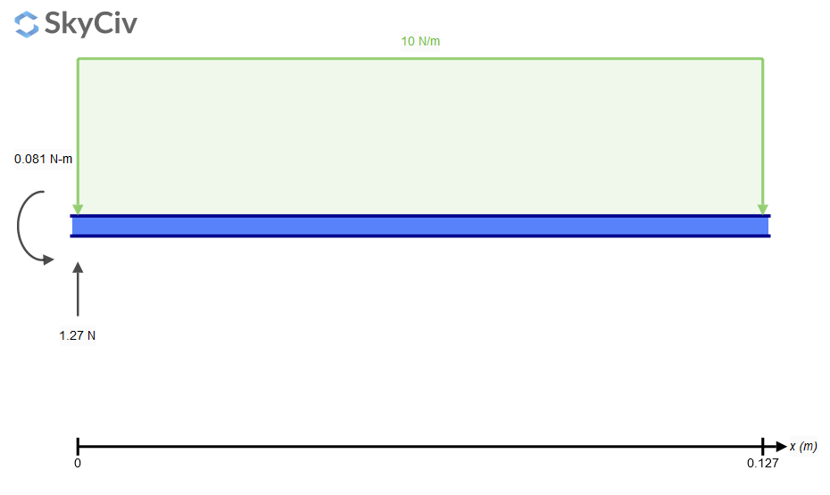
Figure 2: Moment Calculation Visualization

Omni-directional Wheel Control Using Vectors – Jared Hemauer
Each vector equation refers to a wheel and is used to calculate the speed at which each wheel must move for the robot to proceed in the desired direction. The variables in the equation are Vr: the direction the robot must go in, alpha(𝛼): the angle between Vr and a specified reference vector, omega(⍵): the angular velocity, and L: the distance between the center of mass and the center of the wheel. Vw: the rotational speed necessary to move the wheel in the desired direction. A picture is presented below for reference.
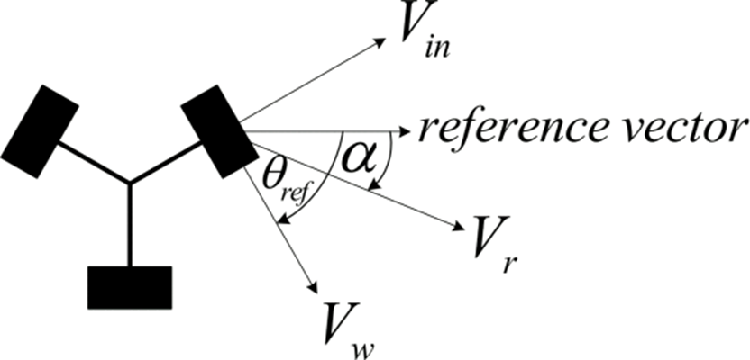
Figure 3: Omnidirectional Wheel Control Visualization

Motor Speed Calculations – Jared Hemauer
Understanding the required rotational speed to attain our desired velocity of 1m/s is critical in determining the best motor for our application. Motor speed calculations use the planned velocity and wheel radius to calculate the needed rotational speed in revolutions per minute (rpm). By taking these parameters into account, we may select an appropriate motor that satisfies the project's speed requirements, resulting in optimal performance and usefulness. Using equation 2, where V represents velocity (1m/s) and r represents the radius of the wheel (29mm), we get an estimated RPM value of 329.3 rpm. This calculation allows us to accurately determine the motor rotational speed required to produce the target velocity, ensuring efficient performance and smooth integration into the project.
 | $$RPM=\frac{60V}{2πr }$$ | (2)

Shear Deformation of PLA for Structural Components – Rylee Horney
Several essential characteristics must be considered while doing engineering calculations for PLA filament shear deformation. For a given shear force (V) of 10N, cross-sectional area (A) of 2.03 mm², length (L) of 127 mm, Young's modulus (E) of 4.107 GPa, and Poisson's ratio (v) of 0.332, the shear deformation (θ) may be calculated using the equation θ = (V * L) / (G * A), where G is the shear modulus of elasticity. Using Equation 3 yields a value of around 1.54 GPa. Substituting the provided values into the shear deformation equation, Equation 4, provides a result of around 4.06 nm. These calculations give useful insight into the mechanical behavior of the PLA filament under shear stresses, which can help with the design and optimization of structures or components made from this material. A better graphic representation of the work is provided here.
 | $$G=\frac{E}{2(1+v)}$$ | (3)
 | $$θ=\frac{V*L}{G*A}$$ | (4)

Instruction Execution Time – Rylee Horney
In engineering calculations of instruction execution time, the parameter Texec reflects the time necessary for instructions to be executed. It is defined in Equation 5, where fcpu is the microcontroller frequency in Hertz. This computation gives critical information about the temporal features of instruction processing within the system. Furthermore, when it comes to power consumption, Equation 6 calculates the power consumed by the microcontroller, with I being the device's current need. By examining these metrics, engineers may efficiently analyze the microcontroller's efficiency and performance characteristics, influencing design decisions and improving system operations for increased functionality and energy economy.
 | $$T_{exec}=\frac{1}{f_{cpu}}$$ | (5)
 | $$P=f_{cpu}*I$$ | (6)

Power of the Motor – Keenan Keams
In engineering calculations of motor power, many essential characteristics are used to estimate the motor's power output. Equation 7 connects power (P) to voltage (E) and current (I), giving a basic grasp of the motor's electrical power consumption. For example, multiplying amperage (I) by voltage (E) provides power output in watts (P), as shown by the formula 6A * 18V = 108 Watts. Power may also be estimated using mechanical characteristics like force and distance over time. To determine how much power is necessary for motor operation, multiply the force by distance and divide by time. Importantly, knowing the link between power and energy, where one watt equals one joule per second, allows for a thorough knowledge of motor performance in terms of both electrical and mechanical components. These calculations are critical for optimizing motor selection and guaranteeing efficient operation within the project's specifications and limits. Note that this computation is currently a work in progress owing to very recent changes in the project.
 | $$P=I*E$$ | (7)

Power Torque Calculation – Keenan Keams
Understanding the link between rotational speed, torque, and power output is critical in engineering power torque calculations when selecting an appropriate motor to satisfy the project's needs. Previous calculations found the wheel's rotational speed to be 329.3 RPM, with each wheel moving at around 109.1 RPM. Torque and wheel RPM are crucial elements for calculating power output. Once the power output has been calculated, it is vital to choose a motor that works at the needed power and RPM, which is 70-80% of its full power capability, to guarantee dependability and durability. Engineers may use these calculations to make educated judgments about motor selection, maximizing performance while maintaining within project restrictions. Below is an image of the work.

Figure 4: Power Torque calculations visualization

Design Concepts

Functional Decomposition
In Figure 5 is the functional decomposition chart for the hamster project. This chart is a flow model to show the main functions needed to fulfill the project's final task. This chart starts with our outcome of the robot moving a patient’s arm. Then the subfunctions are in the second row. These subfunctions are broken down into how they will be processed and how they correlate to each other. This functional decomposition model is important for our project because it allows the team to understand the flow of energy in the robot. This model also breaks down each function into smaller functions that will then help us when it comes to building and coding the robot.
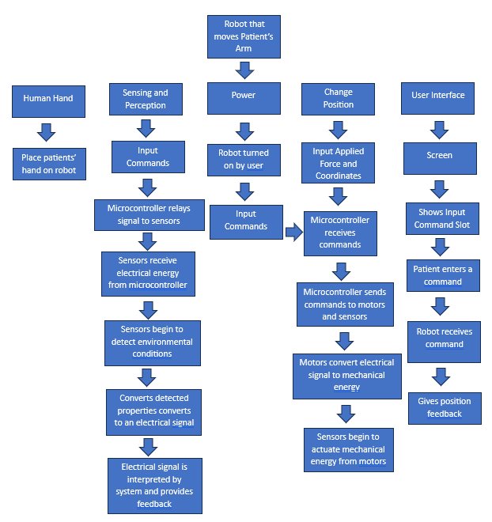
Figure 5: Hamster Project Functional Decomposition

Concept Generation

Hand Attachment System – Joe Lopez
Exploring several attachment approaches for our gadget, we discovered that the Velcro strap concept is both affordable and simple to use, although it does require two hands and may cause discomfort for certain users. The friction fit style is easy and uses soft materials, however it may not produce a snug fit. Alternatively, the air compression fit is the best fitting alternative, but with certain structural problems. Robotic claws provide automated fitting but pose safety risks if the motors fail. Finally, while the clamp approach is cost-effective and simple, it may not provide the requisite snugness. Each approach has specific benefits and downsides that must be carefully considered to provide maximum effectiveness and user pleasure. The chosen sub-design was the Velcro strap.

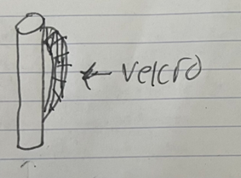
Figure 6: Example of Handle Type – Velcro Strap

Wheel Selection and Layout – Jared Hemauer
Several choices were investigated during the concept development phase of wheel selection and layout for the Hamster project robot to enhance mobility and control while balancing cost and complexity. One alternative involved using three omni-directional wheels, which offered cost-effectiveness and excellent mobility but might provide programming issues. Another concept proposed four omni-directional wheels positioned at angles to improve power, but at a greater cost and more programming complexity. Alternatively, mounting four omni-directional wheels on the sides might increase power, but this would limit horizontal mobility and be more expensive. Despite their higher cost, Mecanum wheels emerged as a popular alternative because to their superior control and simplicity of programming. Finally, using two regular wheels and one caster wheel was judged cheap and simple, but provided limited movement. By carefully analyzing the advantages and disadvantages of each concept, the team hoped to find the best wheel arrangement to efficiently satisfy the project's objectives. The team chose to use three omni-directional wheels in a triangular arrangement. Below are images for clarity.
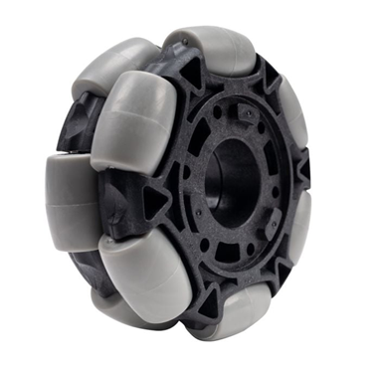
Figure 7: Omni Directional Wheel
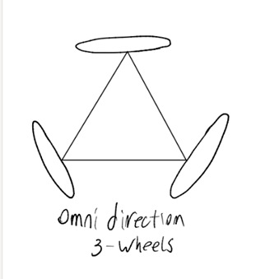
Figure 8: Wheel Layout

Chassis Design – Rylee Horney
During the concept generation phase of the chassis design for the Hamster project robot, an abundance of possibilities was considered to fit the project's components while meeting space limits and compliance with the overall design. The square base emerged as a candidate owing to its capacity to accommodate all components while leaving enough area for a screen. However, concerns that its size would be too huge for a desk. The spherical base, on the other hand, thought to be compatible with a three-wheel design, fitting all components within would be difficult. The dome base was noteworthy for its compatibility with robotic fingers, albeit its height when compared to other designs was a disadvantage. The H base was praised for its economical use of materials, although challenges with internal fittings and additional costs owing to the need for four wheels were observed. Finally, the triangular base was considered adequate for a three-wheel design, despite the restricted interior space. After carefully considering these possibilities, the team chose a chassis design for the project that combines functionality, space usage, and cost effectiveness. The design chosen was the triangular base design shown in Figure 9.
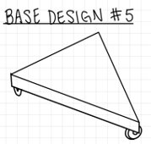
Figure 9: Chassis Design

Screen Placement – Keenan Keams
During the concept creation phase of the screen location for the Hamster project robot, several possibilities were investigated to maximize user experience while balancing durability and cost. One alternative was a screen holder with a separate base on top, which allowed for flexible viewing angles while reducing strain on the user's eyes and neck. However, there were worries about the risk of breakage and increasing costs. Alternatively, incorporating the screen directly into the device was proposed to save components and money, but there were disadvantages such as potential arm occlusion and higher pressure on the user's eyes or neck. Another possibility was to install the screen on top of the gadget, which would save money but provide similar user strain concerns. A screen holder with a bracket was also considered for flexible viewing angles and compatibility with both right and left-handed users, but there were worries about breakage and complexity. Finally, a screen with a side-holding arm was considered for more flexible adjustment choices, although concerns about device length and wear over time were expressed. By carefully examining these possibilities, the team hoped to choose a screen layout design that prioritized user comfort and functionality while minimizing potential downsides. The chosen screen positioning was at a 45-degree angle, as indicated in the figure below.
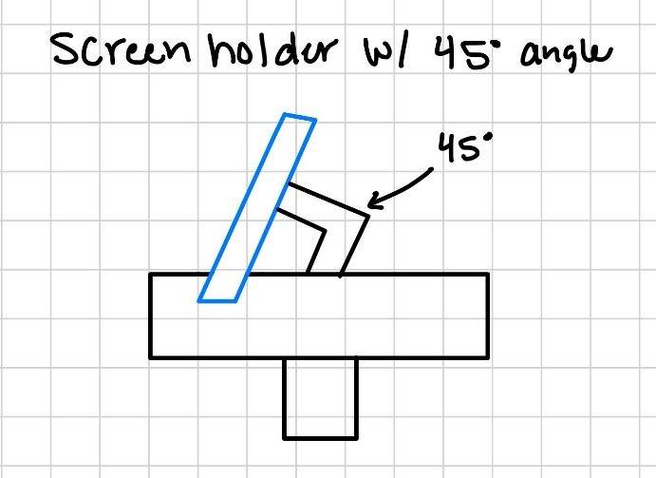
Figure 10: Screen Placement Design

Selection Criteria
The Hamster Project's idea selection criteria were based on engineering needs and prioritized features critical to the device's operation and usability. Each criterion was quantitative and related directly to the project's goals. The criteria included:
- Ease of Use: The most significant factor is the device's ease of operation, setup, and maintenance. Quantification might entail determining the number of steps necessary to activate and use the gadget successfully.
- Cost-Effectiveness: Cost was the second most significant factor, reflecting the project's budget limits. Quantification entailed determining the total cost of materials and manufacturing processes for each design choice.
- Comfort: The third criterion prioritized the device's ergonomics and user comfort while usage. This might be quantified by user surveys and ergonomic studies.
- Snug Fit: Ensuring a snug fit for the item rated fourth, demonstrating the significance of stability and security while in use. Quantification may entail examining dimensional measurements and tolerances to achieve a correct fit on the user’s hand.
- Screen Visibility: This criterion examined how easy it was to view the device's screen, which contributed to user involvement and feedback. Quantification entailed assessing screen size, brightness, and location to achieve maximum visibility.
- Smooth Movement: The device's movement rated sixth, emphasizing the necessity of fluid motion during use. Quantification might entail running tests to determine friction, resistance, and overall movement quality.
Design three emerges as the best option among the finalist ideas for the Hamster Project, excelling in both structural integrity and user comfort. Through extensive moment calculations performed on important junctions, such as the connection between the beam and chassis, design three exhibits greater appropriateness for the required 10 N of force, providing robust performance without compromise. Furthermore, design three's ergonomic considerations make it ideal for attachment to the patient's hand, which corresponds closely to the client's requirement for maximum treatment efficacy. Design three stands out as the most practical and successful stroke rehabilitation aid option because to its emphasis on usefulness, structural stability, and user safety. Design three satisfies the project's objectives while maximizing usability and decreasing danger for stroke patients, thanks to meticulous engineering research and user-centered design.

Concept Selection
In our Pugh chart study, we used design two as a baseline to compare all other designs. This decision was purposeful, as design two performed averagely across all assessed metrics, giving it an appropriate baseline for analyzing alternative possibilities. Design one was regarded as the least favorable, obtaining a score of -1, while design three stood out with a score of +3. This good score suggested that design three outperformed design two in numerous critical areas, prompting us to choose it as the preferable alternative for further development.
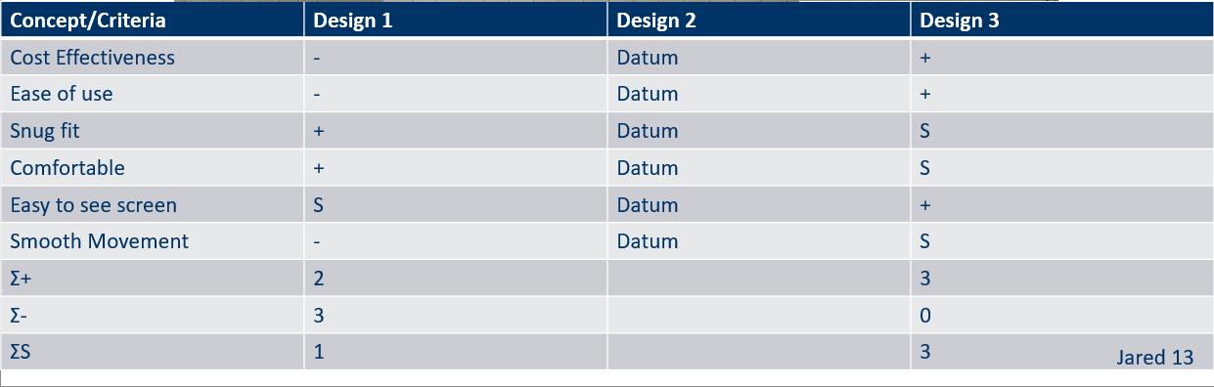
Figure 11: Pugh Chart
The fundamental design of Hamster has changed. The chassis will be manufactured of a tougher plastic rather than PLA. The motors chosen are 280 rpm Planetary Gear Motor, and we are employing motor brackets to keep them secure. The wheels are 100mm omnidirectional, with metal cores for added robustness. The battery that was selected is 12V 6Ah. As for the chassis it is now smaller, and the bottom will be detachable. This is where all the electronic components will be attached for easy access. The handle will be a separate piece that will screw into the chassis. The mechanical components that are outside of the housing will be safe from UV and moisture exposure since its primary use case is indoors in a clean and dry environment. An image of the current CAD model is shown below.

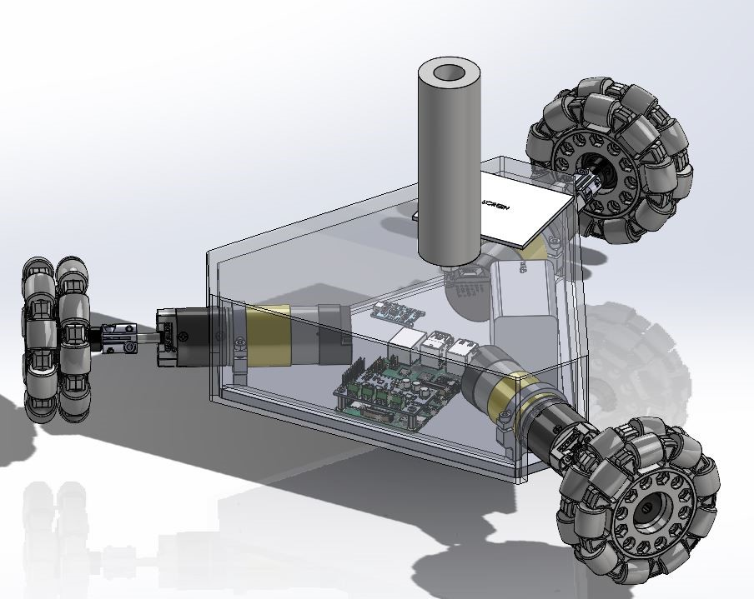
Figure 12: Design Iteration #5

Schedule and Budget

Schedule
The schedule for the Hamster project has been updated to show the current progress for the second semester of the capstone deliverables and can be seen in Appendix B. Included with this schedule is the first-semester timeline. The team has completed most deliverables for the project and course for the second semester at the time this report was written. The remaining deliverables are the Client Handoff, Final Presentation at the Engineering Festival, and Operation/Assembly Manual. The previously mentioned deliverables have been started and this can be seen in Appendix A. By the due date, all assignments will be complete.

Budget
For the Hamster project the team was allotted $1000 from the client. The team was required to fundraise 10% of that amount. Using GoFundMe and asking for help from friends and family the team was able to acquire $250 from the fundraising plan. This allowed the team to have a total budget of $1250. Figure 13 is the breakdown of how this budget was spent.
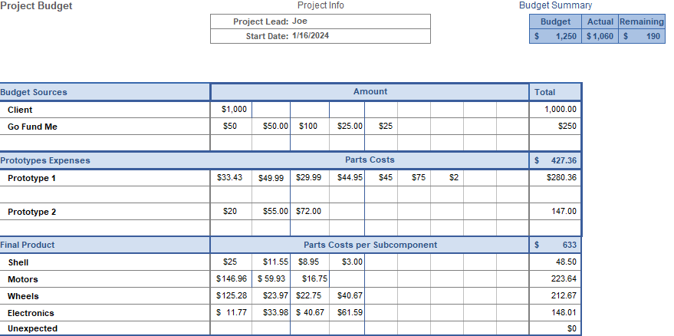
Figure 13: Budget Breakdown for Project

Bill of Materials (BoM)
In the Figure below is the bill of materials for the team’s project. As mentioned in the previous section, the teams budget consisted of $1250 total. In the bill of materials each part is shown. The parts have subcategories such as manufactured or purchased, the manufacturer, the manufacturer’s part number, link to each part, cost per piece, total cost for each based on the number of each part needed. The manufacturing BOM showing parts the team made is included in Appendix B. Provided in the manufacturing BOM is the hours spent manufacturing each part and total hours spent on manufacturing.
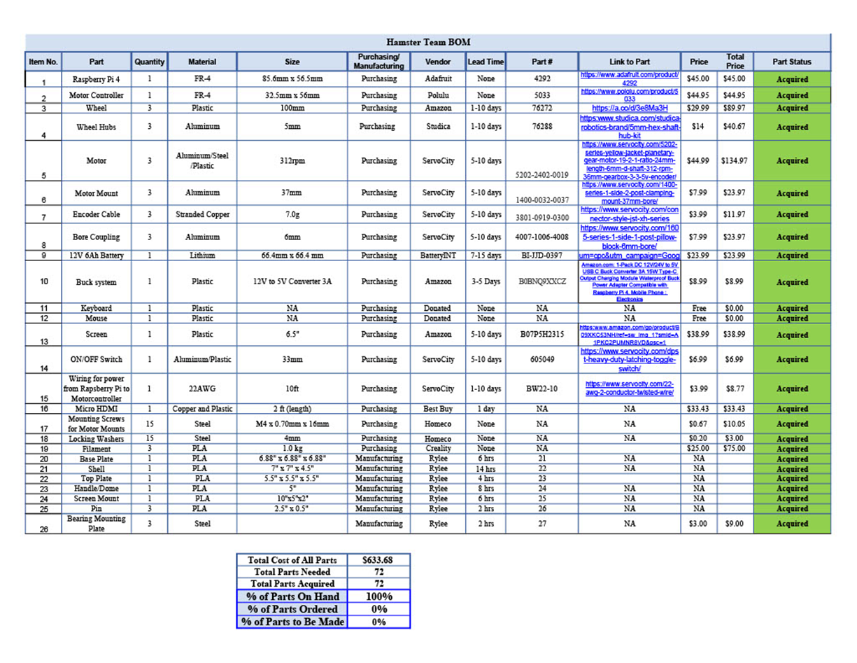
Figure 14: BOM for Hamster

Design Validation and Initial Prototyping

Failure Modes and Effects Analysis (FMEA)
When building and designing the Hamster robot we tried to keep our critical potential failures to a minimum. Some parts are easily replaceable, and some will be a little harder to replace. One of the main potential failures within our system is overvoltage with our electrical components. An overvoltage can ruin the motors and affect the motherboard. One of the ways we are preventing overvoltage is by installing a BMS (Battery Monitor System) that will monitor the current running into the motors. When there is too much current running in the system the BMS switches off and cuts the current. Another potential failure is fatigue failure with parts constantly being used. To prevent this, we are calculating the structure analysis with a higher factor of safety and more load applied to the system. We are also adding replacement parts to our system to help with fatigue. The entire FMEA table can be seen in Appendix C.

Initial Prototyping

Prototype 1
For Prototype 1 the team built the chassis from the original CAD design. The prototype in Figure 15 can be seen, the materials used to build the chassis were PLA filament for the box and handle and 3/8 in 6061 Aluminum plate. The reason for building the chassis for prototype one was the team wanted to answer the question of the actual size and weight of the robot with the design we were considering and if it would meet the engineering requirements that were set. Once the chassis was built, the team found that the weight of the total robot would be over the engineering requirement and the size was too large for the client’s needs. The weight of the robot with all the components that were being considered at the time was over 8 lbs. The engineering requirement the team set was less than 5 lbs. The size of the robot based on the chassis built was going to be 13x13x11 inches. When the prototype was presented to the client, he determined that he did not like the overall size of the robot and would prefer that the design be smaller and weigh less. Based on the client’s wants the team is going to eliminate the aluminum plate, create the box so the bottom is what attaches, and the top will all be one piece. This will allow for the weight limit to be reached as well as the overall size.
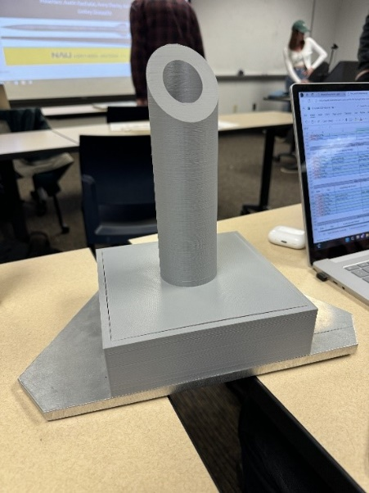
Figure 15: Prototype 1

Prototype 2
Prototype 2 represented the team's attempt to control the motor by connecting the Raspberry Pi with the motor controller. Getting the required libraries is the first step in enabling Python to do the tasks required for motor control. Next, the team will attach the motor controller to the power supply and motor. Since the motor controller is designed to accommodate three motors, certain code adjustments are necessary to ensure proper operation with just one motor attached. The purpose of this adjustment process is to ensure the motor operates smoothly and is integrated into the system. The primary objective of this prototype is to solve the problem of effectively regulating motor speeds. Understanding how to modify these parameters was essential since different desired linear velocities and angles of direction necessitated different speeds and velocities. The team's goal was to make clear how motor speeds are initiated and altered so that these advancements might be built upon in next iterations.

Other Engineering Calculations

Motor Torque Requirements – Joe Lopez
Calculations were made in the way described below to determine the required torque per motor: According to the customer's specifications, the needed force (8) was determined to be 5 Nm across 0.2286 meters, which is the wheel's edge to center. This force divided by three to get the force in newtons per motor (9). As a result, the force per motor was equal to the torque divided by the wheel radius, or 0.05 meters (10). The results of these calculations were 0.364 Nm, or 3.717 kgf-cm, which is the torque needed per motor to reach a total torque of 5 Nm.

 | $$N=\frac{5Nm}{0.2286m}$$ | (8)
 | $$Force per Motor \left(N\right)= \frac{21.87N}{3}$$ | (9)
 | $$7.29N= \frac{xNm}{0.05m}$$ | (10)

Wheel Speeds Using MATLAB – Joe Lopez & Rylee Horney
To determine the speeds of each wheel to produce a velocity of 1 m/s for the robot, MATLAB was used. This calculation is important to the robot design since each motor will have a varying speed and direction. Depending on the direction a wheel may not be moving at all due to the Omni wheels having a set of perpendicular wheels that will move without the use of the motor. The code for this calculation can be seen in Appendix D. In Figure 16 you can see the results that were produced for the robot moving left, right, forward, and back. Eventually, the team hopes this code can be improved to provide a little better result and be used to help with the control of the motors.
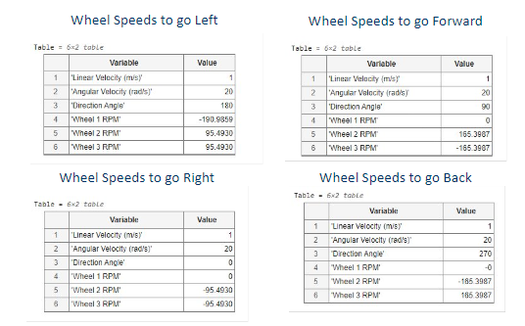
Figure 16: Results from MATLAB Code for Hamster

FEA- Jared Hemauer
Using SOLIDWORKS built-in function SimulationXPRESS we were able to use the max forces that would be applied to the base plate to calculate the stress and deformation applied to it to determine the minimum thickness that we could make the plate. Using a 10lbf load applied perpendicular to a .25 in plate which would be the max load that the base plate would experience the factor of safety came out to be 3.75 which is well within our respectable limit. Using the same load, we calculated the deformation to be 5.58e-3in (.142mm) and the stress applied to be 1.6e3 psi (1.1e7 Pa). From these numbers we are comfortable using a .25in aluminum plate to support our design.
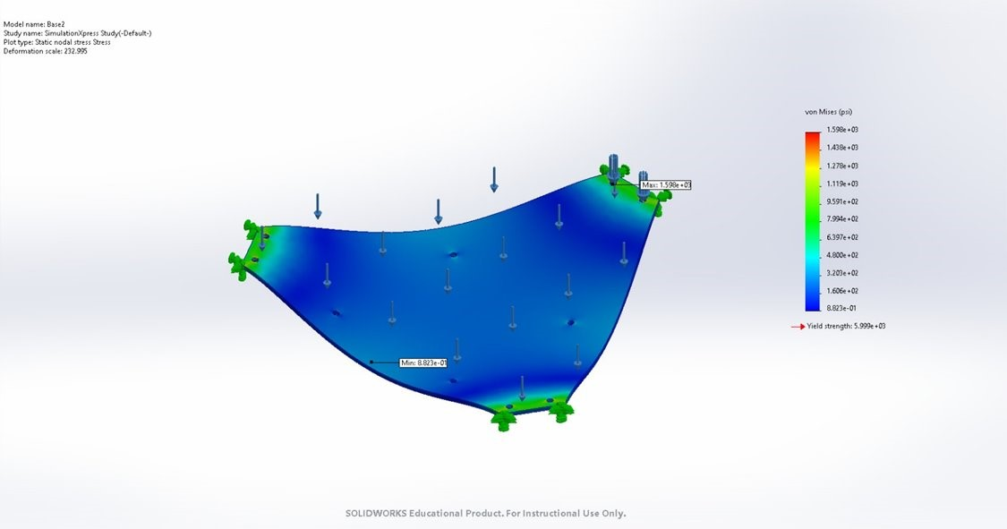
Figure 17: Stress Analysis
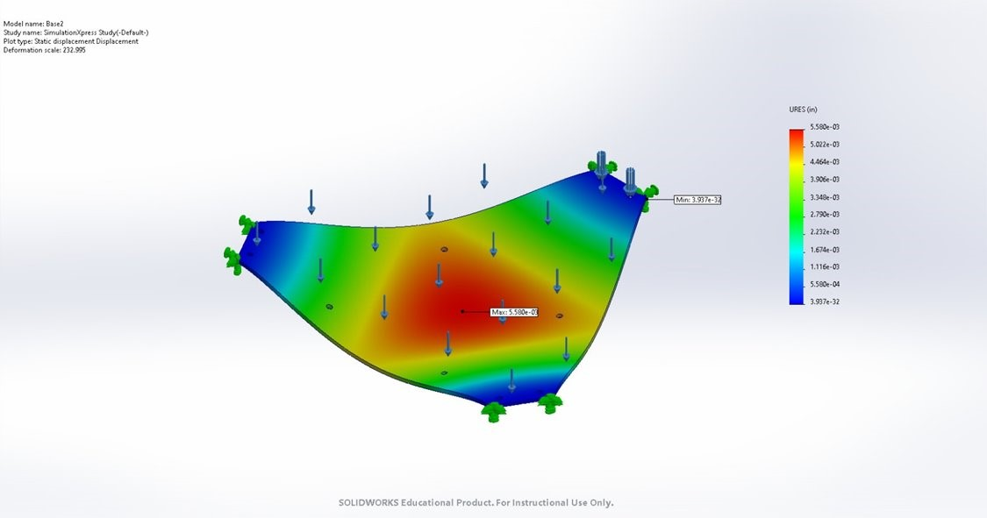
Figure 18: Deflection gradient

Battery Amperage – Keenan Keams
When finding the battery amperage of our system I found the amps our system needed in total to run our system. We are running 3 motors that run at 12V and 6.4 amps with a Raspberry Pi that runs at 5V and 3 amps. When calculating the total amps, I multiplied the gear’s amps by 3 because there are 3 motors and added the Raspberry Pi amps in series which gave me 22 amps within our system. From there I multiplied the total amp value by 0.75 for our 45-minute run sessions and got 16.65 Amp-Hours. With the Amp-Hours number, we were able to look for batteries that would meet the 12V and 16.65 Amp-Hours requirements.
Table 1: Battery Amperage Chart based on Sub-component
Subcomponent | Operating Voltage (V) | Operating Current (A) | Requirements
Motor Gear x3 | 12 | 6.4 | Rechargeable
Raspberry Pi 4 | 5 | 3 | Move 10N
Total | 12 | 22 | 5 N*m Torque
Amp-Hour |  | 16.65 | 45 min sessions
Watt-Hour |  | 199.8 | Max run 80%

Future Testing Potential
Testing procedures for the future include assessing the functionality of the robot once fully built. This includes making sure that all motors are working together and not against each other to produce the 1 m/s velocity required. To test the performance of the robot producing 10N of force the team will attach a 2.2lb weight onto the robot and see if it will still move at 1 m/s. Research may be done on the average weight of an arm and that weight may be applied to the chassis of the robot to test for failure in the design and reactions of smaller components such as the axles for each wheel.

Final Hardware

Final Physical Design
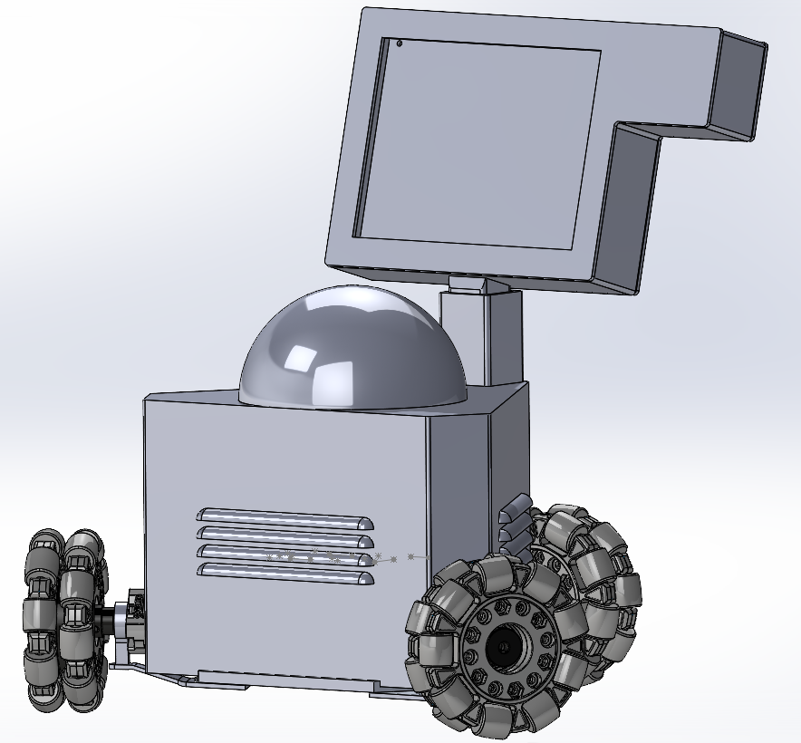
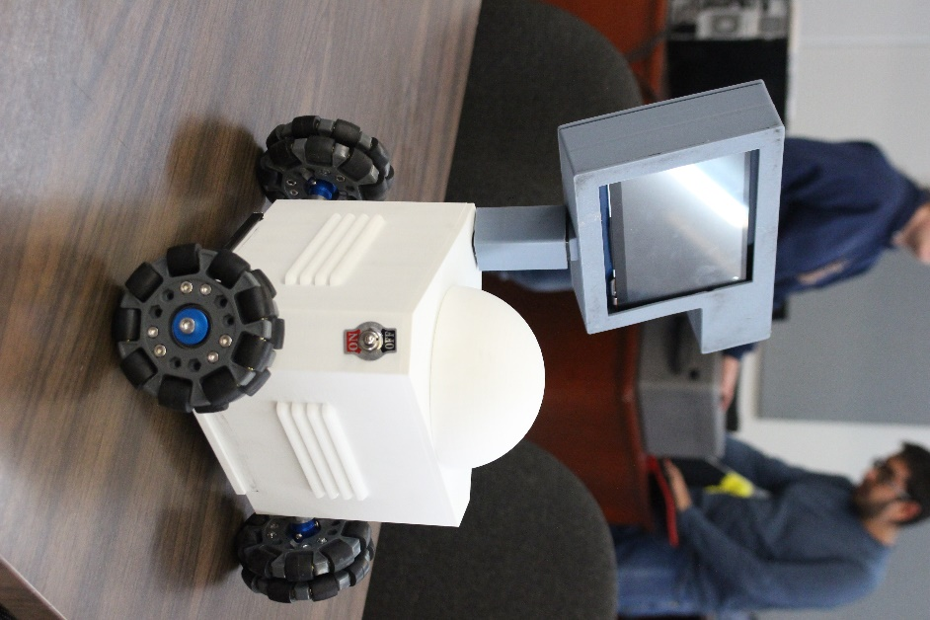
Figure 20: Final Iteration CAD
Figure 19: Final Prototype
Figures 19 & 20 shows the completed CAD and physical prototype of the final iteration of this project. The design includes three omnidirectional wheels each attached to a motor. A two layered design seen in Figure # was used to make the device more compact and was used to mount the battery, the raspberry pi, the motor controller, and the buck converter.
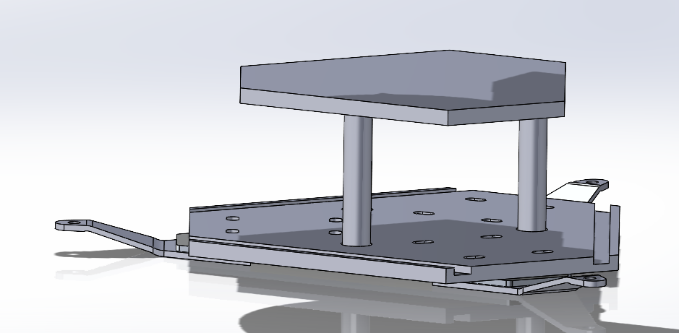
Figure 21: 2 Layered Design in CAD

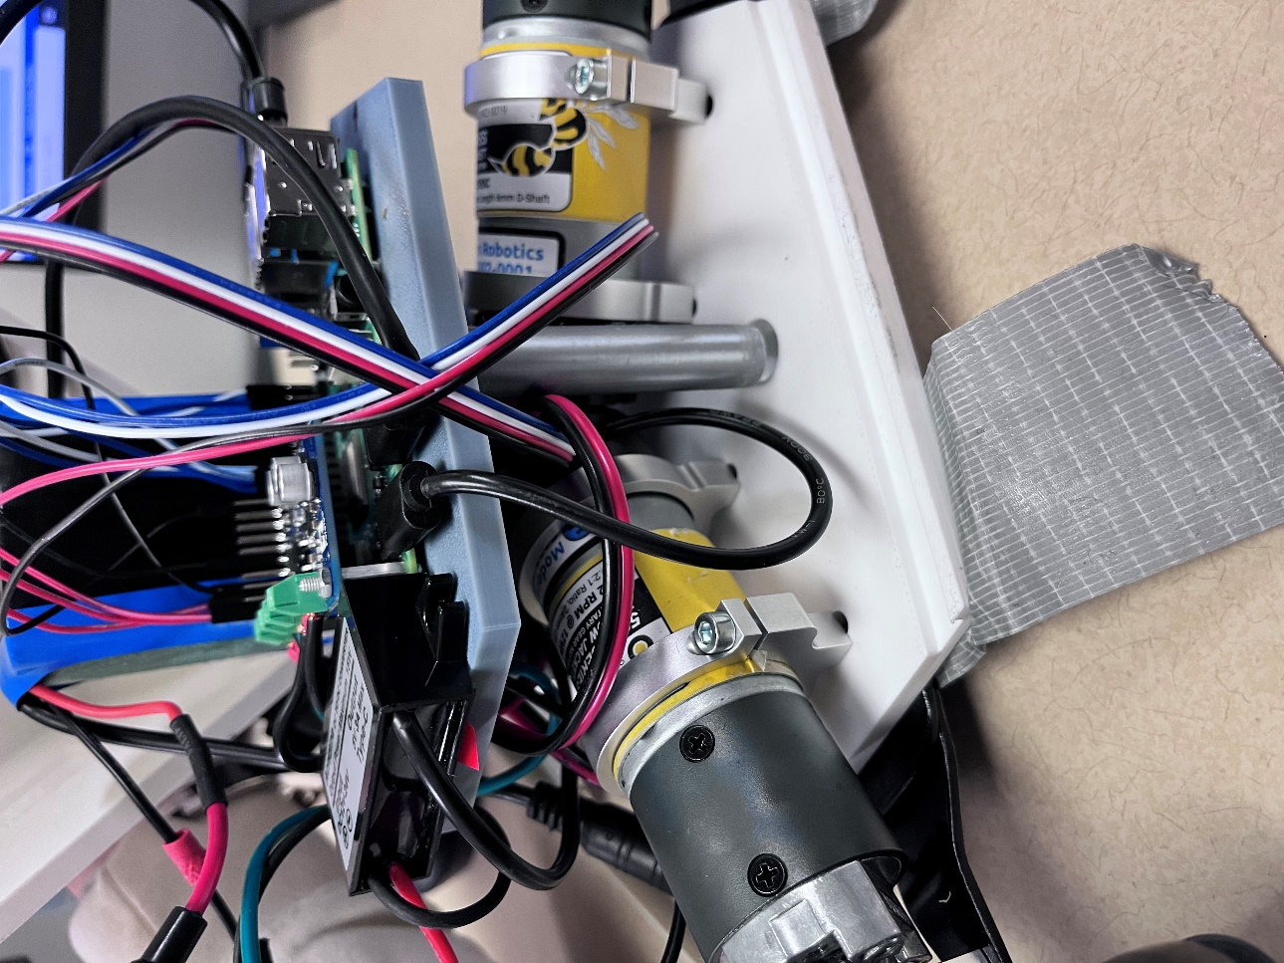
Figure 22: Layered Design in Physical Form
Figure 22 shows the shell which is used to conceal all the internal components and includes louvers on each side of it to allow for proper air circulation. The top is where the dome or handle will be inserted and at the front is where the screen mount will be inserted and the cables will run along the inside of it.
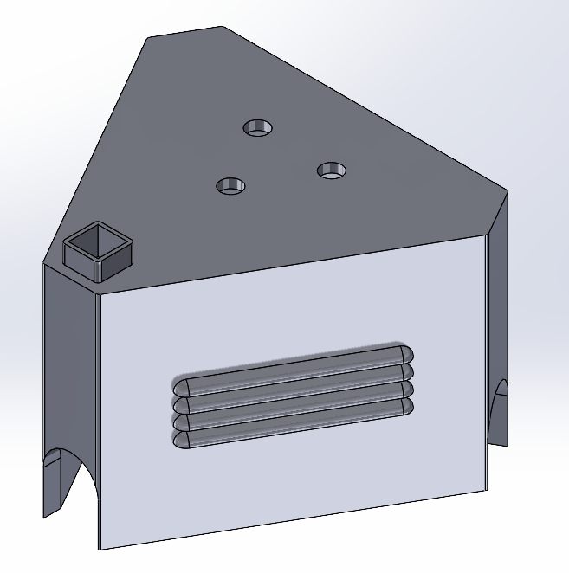
Figure 23: CAD of Shell
A main concern that the team had was about the motor shafts deforming under the stress of the device itself and any added weight from the user. In order to add more support to the shafts bearing mounts were added at the base of each shaft and where mounted to the base of the device using steel brackets. The CAD and real-life design can be seen in Figures 24 & 25.
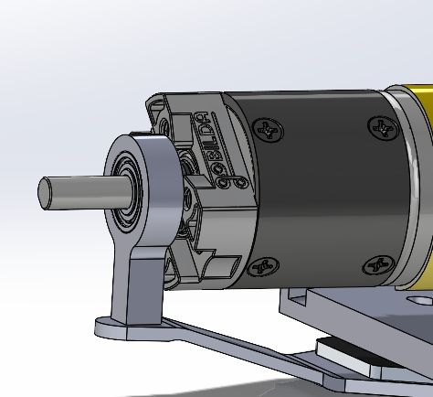
Figure 24: CAD of Bearing Mount

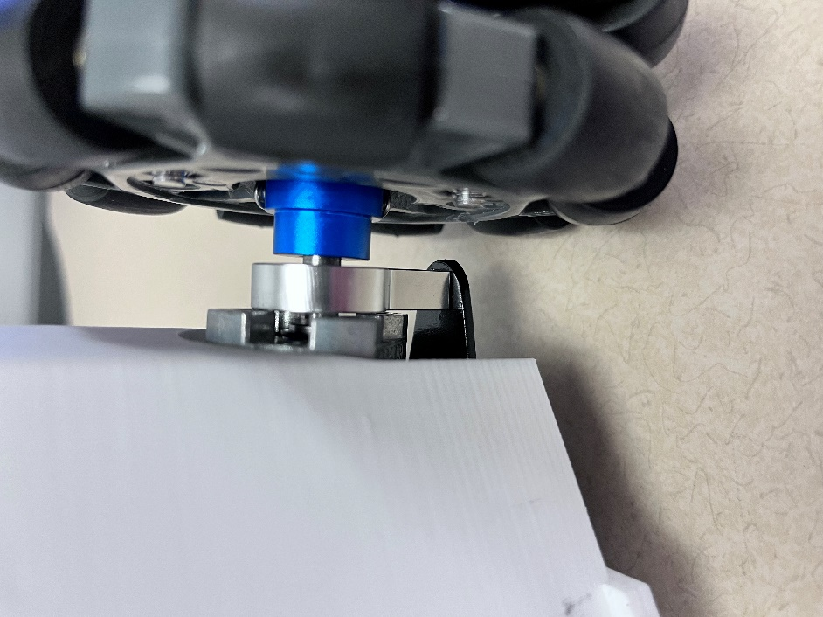
Figure 25: Bearing Mount in Physical Form
The screen housing assembly in Figure 26 holds the screen and all the necessary cables. The screen mounts to a plate inside the housing assembly with a cut-out on the right side to store the cables in the back panel for cleaner cable management. The cables then run through the shaft that holds it up to allow for them to reach the Raspberry Pi. The large bulge on the right side is necessary since that is where the HDMI and micro-USB ports are on the screen.
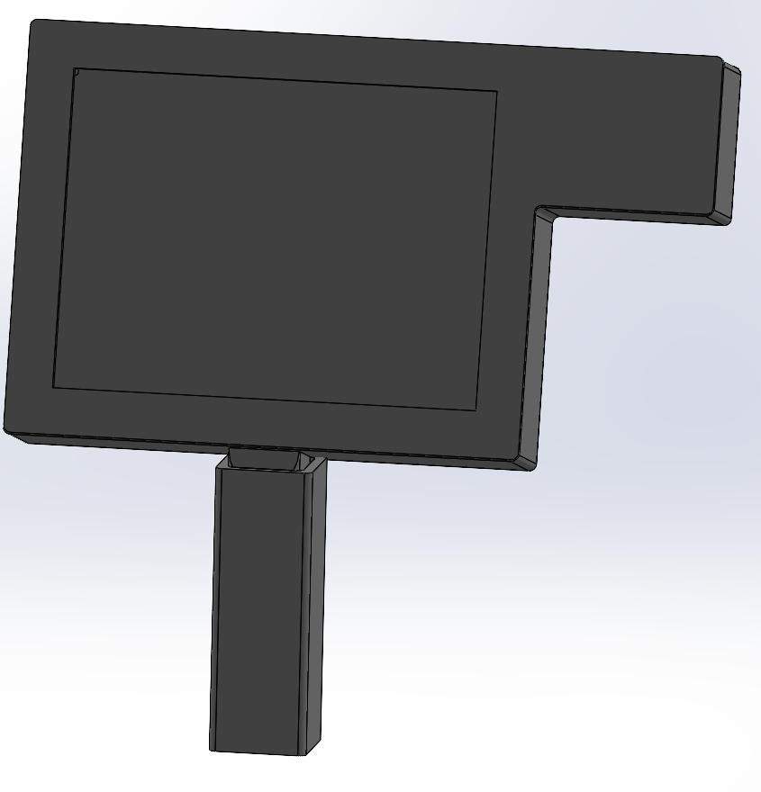
Figure 26: CAD of Screen Assembly

Final Testing

Top level testing summary table
Test # | Requirements Being Tested | Equipment Needed | Other Resources
1. Prony Brake | CR2: Speed of 1m/s  CR3: Produce 10N of force  ER1: Output a force of 10N | Spring scales, leather strap, 3D printed drum, tachometer | Thermal Fluids Lab (Rm 111)
2. Force Output Test | CR3: Produce 10N of force  CR4: Internal friction of 5N or less | Digital scale | Raz Lab (ROTC 137)
3. Duration | CR6: Run for 30 minutes on a single charge  ER2: Battery life at least 30 minutes  ER3: Produce enough current for all components | Timer | Testing Space
4. Position Test | CR5: Move less than .1mm when motors are turned off  CR7: Receive commands from the computer and return x,y coordinates | Tape measure | Testing Space
Table 2: Top Level Testing Table
Validating the robot's performance against essential requirements was the main goal of the Hamster Project's testing phase. Using a Prony Brake configuration that included spring scales, a tachometer, and tools from the Thermal Fluids Lab, the robot's speed and force capabilities were tested, verifying that it could reach 1 m/s and generate 10 N of force. The device needed less than 5 N to move while the motors were off, according to a test conducted at the Raz Lab to measure internal friction. The battery's capacity to function continuously for half an hour was evaluated. The robot's ability to measure movement accuracy and ensure compliance to positional and communication standards was lastly validated by a position test. These testing revealed areas for more improvement while highlighting the present prototype's capabilities.

Detailed Testing Plan

Force Output Test

Summary
Performing the force output test on the robot will verify that the robot can produce an output force of 10 N based on the customer requirements. There will also be confirmation on if by a patient pushing the robot without the motors in use that they will only have to use 5 N of force to move the robot. The accuracy of the force input to the robot will also be measured in this test to ensure it is within +/- 1N. To perform this test, the equipment needed is a digital scale. The test will involve place the digital scale against the wall and having the robot push against it. The variable that will be isolated for measurement in this test is the force that is measured on the scales when the robot is producing various force amounts. No variables will need to be calculated from the results of this test. The results will be numerical values that will show what output force the robot is producing when in use and when being manually pushed.

Procedure
Step 1. Place digital scale against the wall and place robot against scale.
Step 2. Turn on robot, using the code input 0 N for the force to verify scale is reading properly.
Step 3. Increase force by 2 N increments up to 10 N of force. Record the value that the scale is reading at each interval.
Step 4. Once complete with the motors portion of this test, move robot back to the location where the scale reads 0 N of force.
Step 5. Then use someone's hand, push the robot until it moves slightly, and a second person needs to record the force applied once the robot moves.
Step 6. Repeat Step 5 five times and ensure that robot is moved back to the neutral location where the scale reads 0 N.

Results
The results showed that the device can output a max of 20 Newtons, but this number can be greater since the wheels would slip on the ground when outputting high forces. The internal friction test determined that it takes up to 7 newtons to move the device when turned off. The device accuracy was not as precise as the client wanted, being accurate within +/- 2 Newtons.

Prony Brake

Summary
With the Prony Brake test the team will be able to answer the question if the motors that were selected based on calculations can produce the right amount of torque at certain speeds. These force measurements will verify that the robot will be able to output 10N of force against the patient’s hand based on customer requirement three. From our customer’s third requirement this leads back to the team’s first engineering requirement. To perform this test the team will have to design a Prony brake test rig. An example of this test rig can be seen in Figure 1. For this testing structure the equipment needed is a drum that will fit onto the shaft of the motor, a tachometer, a nylon rope, two hooks that are threaded, two threaded washers, and two scales.

Procedure
Step 1. Setup the testing rig. Place scales on hooks, secure nylon rope to scales, attach the drum to the shaft of the motor, and place motor on stand. As parts of the test rig are being put together verify that none of the parts are damaged.
Step 2. Once the motor is placed in the rig, wrap the rope around the motor's drum. Check that the rope is evenly spaced on the drum to prevent twisting on the shaft.
Step 3. Turn on the power supply to the motor
Step 4. Using the code for the robot, type in the desired RPM and start the motor.
Step 5. Once the motor is running using the tachometer record the speed that the shaft is moving without a force applied.
Step 6. Begin applying a force to the motor shaft in increments of 2N up to 10N.
Step 7. Record each measurement for the force as well as the RPM using the tachometer.

Results
The Prony Brake produced the expected outcomes. The observed motor torque constant was.503 Nm/A, and the angular velocity dropped as the torque rose. We were able to test the motors under load and confirm that they were powerful enough to provide the required force, which made this test crucial.

Position Test

Summary
The position test helps our hamster system locate itself within a given area. In this test, we are going to run the system for a certain time and measure the distance traveled within that time and speed. We will need a measuring tape, the hamster robot, and a good amount of space to do the test. The variables that we isolated are distance in meters, time in seconds, and speed of the motors in M/s. The only variable we need to calculate is the distance traveled over a certain time. We enter the speed of the motors for a certain time into our code and measure the distance the robot travels. After the distance is measured, we add that to the code to give us a boundary for the robot to stay in.

Procedure
Step 1. Clear a good amount of space for the robot.
Step 2. Set up the robot with a fully charged battery.
Step 3. Run the robot in one direction with speed and time.
Step 4. Measure distance traveled with measure tape.
Step 5. Repeat steps 3 and 4 with different speed and time.
Step 6. Add results to our raspberry pi code.

Results
Unfortunately, this test was determined to be inconclusive due to hardware restrictions. The primary hardware problem came from the motor controller's usage of crucial Raspberry Pi pins that the encoder would have used if they were available. Finding a solution to this problem or utilizing different controllers and encoders would be future work on this test.

Duration Test

Summary
With this duration test, we will check the time span of the battery with the electrical load of the robot. The battery will have to have enough amperage to supply the motors, screen, and internal components of the robot while meeting the desired time. The test will help us verify engineering requirements 2 and 3 and customer requirement 6 of the battery running for a minimum of 30 minutes on a single charge. For the test, we need a working robot and a stopwatch to verify the time. We put the robot through different forces and speed simulations and measured the time it takes the battery to run out. The variable that is being isolated for this test is the run time of the battery. If the battery does not meet the run time of 30 minutes, we have to recalculate the amperage of the whole system and verify it is within our battery period.

Procedure
Step 1. Wire the system up with a charged battery.
Step 2. Run the training simulation
Step 3. Measure the time it takes for the battery to die out
Step 4. Record simulations that are used and run the system through a different simulation.

Results
With the test being ran the robot proved to preform very well, when there was no load on the device the robot ran for 30 minutes in addition to the time the team was working on it before. After fully charging the battery the test was ran again this time with a hand on it to simulate load and it preformed great once again.

Future work
Even though the Hamster Project accomplished several significant milestones, a few things still need to be improved in order to completely fulfill the project's objectives and increase the device's effectiveness. Since the current prototype of the robot is larger and heavier than planned, this is a major area for development. To reduce the overall footprint without sacrificing structural integrity, future research should investigate the use of substitute materials, such as lightweight composites or advanced 3D printing technologies. Optimizing the internal component architecture may also reduce wasted space, which would make the design even more portable and small.

Increasing the precision of force control is another top target for future development. The robot's force control precision of ±2 N is below the intended ±1 N threshold, even though it achieved the goal speed and applied force criteria. This problem could be resolved by improving control algorithms and adding more precise sensors or actuators. Better real-time force changes would be made possible by these improvements, enhancing the device's usability and efficacy. In addition, integrating the integrated motor encoders—one of the project's core objectives—remains an important obstacle. The present prototype was unable to use them due to hardware constraints, but the robot's navigation and movement accuracy would be greatly increased by switching to more powerful microcontrollers or motor controllers with improved encoder support.

Lastly, more work should be done to incorporate sophisticated features and optimize the program. The robot may be more effective and user-friendly with better control algorithms, better integration of sensors, and an easier-to-use interface. Both caregivers and patients may benefit from investigating remote connection for data recording and progress monitoring. Thorough user testing with stroke patients and therapists will be necessary to confirm the robot's functionality and collect input for future iterations. By tackling these issues, the Hamster Project might develop into a highly effective and efficient solution that closes the gap between high-tech rehabilitation and cost.

CONCLUSIONS
The goal of the Hamster Project was to create a small, omnidirectional robotic device that would improve patient movement while undergoing treatment in order to aid in stroke recovery. Portability, a speed of 1 m/s, force application of up to 10 N, and a minimum 30-minute duration were among the crucial requirements. The device also needs to incorporate cost-effectiveness, a system user interface, and be comfortable for patients to use. Iterative design and testing produced notable improvements over the course of the two semesters. In order to ensure accurate and smooth motion, the team decided on a triangular chassis design with three omnidirectional wheels. The device has an intuitive UI to improve user experience, optimal battery specs for long-term performance, and a Raspberry Pi for reliable processing and motor control. The prototype was in line with client expectations after difficulties, such as weight and size restrictions, were successfully resolved through material optimization and redesign. The successes of these semesters establish the Hamster Project as a viable option for stroke rehabilitation at home, providing a convenient and affordable substitute for conventional treatment techniques. This project's foundation lays the platform for future development and implementation, which might completely transform the availability of stroke recovery options globally.

REFERENCES
[1]J. Brackenridge, L. V. Bradnam, S. Lennon, J. J. Costi, and D. A. Hobbs, “A Review of Rehabilitation Devices to Promote Upper Limb Function Following Stroke,” Neuroscience and Biomedical Engineering, vol. 4, no. 1, pp. 25–42, Mar. 2016, Available: https://www.ingentaconnect.com/content/ben/nbe/2016/00000004/00000001/art00006
[2]P. Weiss, M. Heldmann, A. Gabrecht, Achim Schweikard, T. M. Münte, and E. Maehle, “A Low Cost Tele-Rehabilitation Device for Training of Wrist and Finger Functions After Stroke,” A low cost tele-rehabilitation device for training of wrist and finger functions after stroke, Jan. 2014, doi: https://doi.org/10.4108/icst.pervasivehealth.2014.255331.
[3]T. Georgiou, S. Holland, and Janet, “Wearable haptic devices for post-stroke gait rehabilitation,” Open Research Online (The Open University), Sep. 2016, doi: https://doi.org/10.1145/2968219.2972718.
[4]L. Riek, Healthcare robotics, vol. 60, no. 11, Oct. 2017, doi: https://doi.org/10.1145/3127874.
[5]J. Duval et al., “Designing Spellcasters from Clinician Perspectives,” ACM Transactions on Accessible Computing, vol. 15, no. 3, Apr. 2022, doi: https://doi.org/10.1145/3530820.
[6]C. Axel et al., “Engineering Rehabilitation: Blending Two Tool-supported Approaches to Close the Loop from Tasks-based Rehabilitation to Exercises and Back Again,” Proceedings of the ACM on human-computer interaction, vol. 7, no. EICS, pp. 1–23, Jun. 2023, doi: https://doi.org/10.1145/3593229.
[7]Dharmaraja Selvamuthu and P. Tardelli, “Partial Observed Fluid Queue Model for Rechargeable Batteries,” Partial Observed Fluid Queue Model for Rechargeable Batteries, May 2020, doi: https://doi.org/10.1145/3388831.3388856.
[8]R. Ramirez, “How to Power Your Raspberry Pi With a Battery,” Circuit Basics, Jul. 29, 2021. https://www.circuitbasics.com/how-to-power-your-raspberry-pi-with-a-lithium-battery/
[9]S. Hu, H. Chen, and Y. Shao, “Triangular Omnidirectional Wheel Motion Control System,” OALib, vol. 07, no. 08, pp. 1–8, 2020, doi: https://doi.org/10.4236/oalib.1106677.
[10]Pololu, “Pololu Motoron Motor Controller User’s Guide,” www.pololu.com. https://www.pololu.com/docs/0J84/all (accessed Apr. 27, 2024).
[11] John Ryan C. Dizon, Alejandro H. Espera, Qiyi Chen, Rigoberto C. Advincula,Mechanical characterization of 3D-printed polymers, Additive Manufacturing, Volume 20, 2018, Pages 44-67
[12] E. Macdonald et al., "3D Printing for the Rapid Prototyping of Structural Electronics," in IEEE Access, vol. 2, pp. 234-242, Dec. 2014
[13] C. Wang et al., “Trajectory tracking of an omni-directional wheeled mobile robot using a model predictive control strategy,” Applied Sciences, vol. 8, no. 2, p. 231, Feb. 2018. doi:10.3390/app8020231
[14] K. Shabalina, A. Sagitov and E. Magid, "Comparative Analysis of Mobile Robot Wheels Design," 2018 11th International Conference on Developments in eSystems Engineering (DeSE), Cambridge, UK, 2018, pp. 175-179
[15] J. Inthiam and C. Deelertpaiboon, "Self-localization and navigation of holonomic mobile robot using omni-directional wheel odometry," TENCON 2014 - 2014 IEEE Region 10 Conference, Bangkok, Thailand, 2014, pp. 1-5
[16] Centiva, “Driving Mecanum wheels omnidirectional robots,” roboteq, https://www.roboteq.com/applications/all-blogs/5-driving-mecanum-wheels-omnidirectional-robots (accessed Mar. 15, 2024).
[17] I. Siradjuddin et al., “A General Inverse Kinematic Formulation and Control Schemes for Omnidirectional Robots,” 2021
[18] “Engineer Essentials LLC - creators of GD&T Basics,” GDT Basics, https://www.gdandtbasics.com/gdt-symbols/ (accessed Apr. 26, 2024).
[19] American Standards - ANSI (American National Standard Institute). New York, NY: ANSI/ASME.
[20] Ansys 2021R2, “Ansys Fluent Workbench Tutorial Guide”, 2021.
[21] M. K. Parai, B. Das, and G. Das, “An Overview of Microcontroller Unit: from Proper Selection to Specific Application,” vol. 2, no. 6, 2013
[22] J.-D. Warren, J. Adams, and H. Molle, Arduino Robotics. New York: Springer, 2011.
[23] J. Collins, S. Chand, A. Vanderkop, and D. Howard, “A Review of Physics Simulators for Robotic Applications,” IEEE Access, vol. 9, pp. 51416–51431, 2021, doi: 10.1109/ACCESS.2021.3068769.
[24] “13.3.2. Controllability of Wheeled Mobile Robots (Part 1 of 4) – Modern Robotics.” Accessed: Feb. 03, 2024. [Online]. Available: https://modernrobotics.northwestern.edu/nu-gm-book-resource/13-3-2-controllability-of-wheeled-mobile-robots-part-1-of-4/#department
[25] “10.1. Overview of Motion Planning – Modern Robotics.” Accessed: Feb. 03, 2024. [Online]. Available: https://modernrobotics.northwestern.edu/nu-gm-book-resource/10-1-overview-of-motion-planning/#department
[26] V. C. Pinto et al., “Comparative Failure Analysis of PLA, PLA/GNP and PLA/CNT-COOH Biodegradable Nanocomposites thin Films,” Procedia Engineering, vol. 114, pp. 635–642, 2015, doi: 10.1016/j.proeng.2015.08.004.
[27] “New Arduino Tutorials - YouTube.” Accessed: Feb. 03, 2024. [Online]. Available: https://www.youtube.com/
[28] “Pololu - 3.2.4. Connecting a Motoron controller for Raspberry Pi.” Accessed: Apr. 22, 2024. [Online]. Available: https://www.pololu.com/docs/0J84/3.2.4
[29] D. Xue and Y. Chen, System Simulation Techniques with MATLAB and Simulink. John Wiley & Sons, 2013.
[30] D. Staple, Learn Robotics Programming: Build and control autonomous robots using Raspberry Pi 3 and Python. Packt Publishing Ltd, 2018.
[31]Zdzislaw. Gosiewski and Zbigniew. Kulesza, Mechatronic systems and materials III. Stafa-Zurich, Switzerland: Trans Tech Publications, 2009.
[32] Mordechai. Ben-Ari and Francesco. Mondada, Elements of Robotics, 1st ed. 2018. Cham: Springer Nature, 2018. doi: 10.1007/978-3-319-62533-1.
[33] C. A. Jara, J. A. Corrales Ramón, C. A. Jara, and J. A. Corrales Ramón, Robotic Platforms for Assistance to People with Disabilities. Basel: MDPI - Multidisciplinary Digital Publishing Institute, 2022.
[34] Y. Hsieh, C. Wu, K. Lin, G. Yao, K. Wu, and Y. Chang, “Dose–Response Relationship of Robot-Assisted Stroke Motor Rehabilitation,” Stroke, vol. 43, no. 10, pp. 2729–2734, Oct. 2012, doi: https://doi.org/10.1161/strokeaha.112.658807.
[35] K. Lo, M. Stephenson, and C. Lockwood, “Adoption of robotic stroke rehabilitation into clinical settings: a qualitative descriptive analysis,” International journal of evidence-based healthcare, vol. 18, no. 4, pp. 376–390, 2020, doi: 10.1097/XEB.0000000000000231.
[36] Ozhan Ozen, Karin A. Buetler, Laura Marchal-Crespo, and Laura Marchal-Crespo, “Promoting Motor Variability During Robotic Assistance Enhances Motor Learning of Dynamic Tasks,” Frontiers in neuroscience, vol. 14, 2021, doi: 10.48350/151814.
[37] Electrical Technology, “What is the Main Difference Between AC and DC Motor?,” ELECTRICAL TECHNOLOGY, Jun. 12, 2020. https://www.electricaltechnology.org/2020/06/difference-between-ac-dc-motor.html
[38] J. García, Ed., Encyclopedia of electrical and electronic power engineering. Amsterdam, The Netherlands ; Elsevier, 2023.
[39] B. V. Manikandan, P. Kiruthickroshan, M. V. Kumar, and L. Chandrasekeran, “Battery Management System with Charge Monitor and Fire Protection for Electrical Drive,” in E3S Web of Conferences, 2023, vol. 387. doi: 10.1051/e3sconf/202338701002.
[40] A. S. Hollinger, D. R. McAnallen, M. T. Brockett, S. C. DeLaney, J. Ma, and C. D. Rahn, “Cylindrical lithium‐ion structural batteries for drones,” International journal of energy research, vol. 44, no. 1, pp. 560–566, 2020, doi: 10.1002/er.4937.
[41]“Ekso GTTM Robotic Exoskeleton Cleared by FDA for Use With Stroke and Spinal Cord Injury Patients,” Ekso Bionics Holdings, Inc., Apr. 04, 2016. https://ir.eksobionics.com/press-
releases/detail/570/ekso-gt-robotic-exoskeletoncleared-by-fda-for-use-with
[42]Kinova, “Robotic arm,” Kinova - Assistive Technologies. https://assistive.kinovarobotics.com/product/jaco-robotic-arm

APPENDICES

Appendix A: Gantt Chart for Project

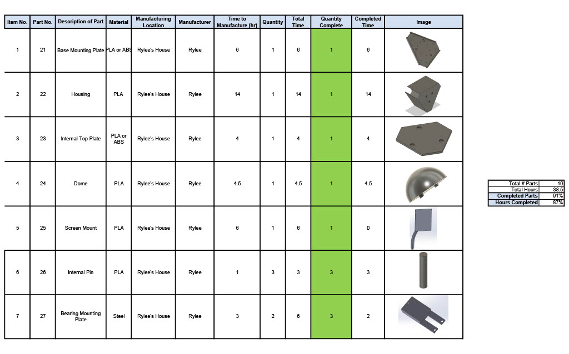
Appendix B: Manufacturing BOM

Appendix C: FMEA Table
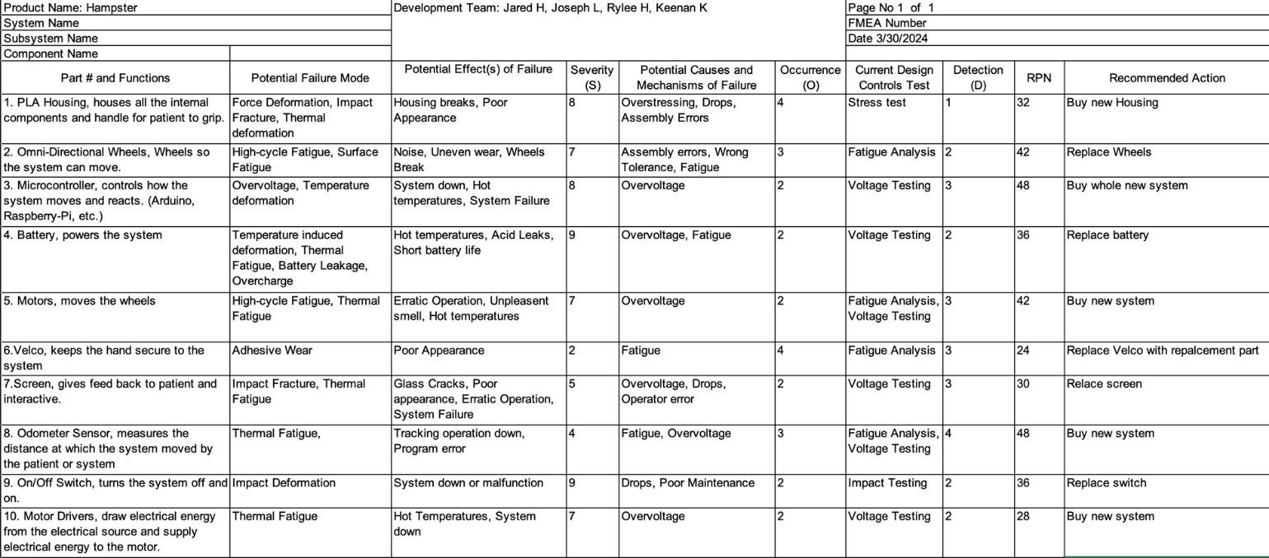

Appendix D: MATLAB Code for Section 6.3.2
% Constants
d = 0.2032; % Distance from center of robot in meters
Mass = 3.17515; % Mass in Kg
radius = 0.051; % Radius of wheel in meters
k = 0.503; % Motor constant in Nm/mA
conversionFactor = 10.197162; % Conversion factor from Nm to kg.cm

% Prompt the user for input variables
AngForce = input('Enter the angular force (in Nm): ');
ForceMag = input('Enter the force magnitude (in N): ');
angle_Deg = input('Enter the angle in degrees: ');

% Convert angle from degrees to radians
angle_Rad = deg2rad(angle_Deg);

% Calculate the inputted forces
OForce = AngForce;
XForce = ForceMag * cos(angle_Rad);
YForce = ForceMag * sin(angle_Rad);

% Calculate accelerations
OAcc = OForce / Mass;
XAcc = XForce / Mass;
YAcc = YForce / Mass;

% Forces corrected
OForce_Corrected = Mass * OAcc;
XForce_Corrected = Mass * XAcc;
YForce_Corrected = Mass * YAcc;

% Define the Torque Coefficients Matrix (updated J matrix)
J = [
-d, 1, 0; % Motor 1
-d, -0.5, -sin(pi / 3); % Motor 2
-d, -0.5, sin(pi / 3) % Motor 3
];

% Create the forces matrix
Forces = [OForce_Corrected; XForce_Corrected; YForce_Corrected];

% Calculate torque for each motor using matrix multiplication
Torque = (1 / radius) * (J * Forces);

% Apply a threshold for near-zero torque to avoid small values due to floating-point errors
Torque(abs(Torque) < 1e-6) = 0; % Set very small values to 0

% Convert torque to kg.cm
Torque_kgcm = Torque * conversionFactor;

% Solve for amps in milliamps
% Since k is in Nm/mA, convert it to Nm/A for calculations
k_A = k * 1000; % Convert k to Nm/A
Amp_mA = (Torque / k_A) * 1000; % Calculate current in mA

% Display results
disp('Accelerations (OAcc, XAcc, YAcc):');
disp([OAcc, XAcc, YAcc]);

disp('Forces Corrected:');
disp([OForce_Corrected, XForce_Corrected, YForce_Corrected]);

disp('Torque (in kg.cm):');
disp(Torque_kgcm);

disp('Amp1, Amp2, Amp3 (in mA):');
disp(Amp_mA);

